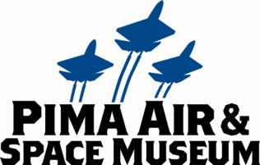

**FOR IMMEDIATE RELEASE**

Mary E Emich  
Director of Marketing, Sales and Visitor Services  
Arizona Aerospace Foundation  
6000 East Valencia Rd  
Tucson, AZ 85756  
Phone 520 618-4805  
[memich@pimaair.org](mailto:memich@pimaair.org)

**REGISTER NOW FOR PIMA AIR & SPACE MUSEUM’S 2014 GREAT PAPER AIRPLANE FLY-OFF**

**NEW THIS YEAR:**

* **NEW PRIZES FOR THE WINNERS: including A FLIGHT IN A PRIVATE AIRPLANE!**
* **INCREASED NUMBER OF CONTESTANTS, WITH A MINIMUM OF 2 TOSSES PER CONTESTANT**
* **EXPANDED DAY OF FUN**
* **SPECIAL EDUCATOR WEBPAGE**
* **FAMILY COMPETITION**

Tucson—Feb. 8, 2014 Registration is underway for the Pima Air & Space Museum’s 3rd Annual Great Paper Airplane Fly-Off scheduled for Feb. 8, 2014 (10 a.m. to 4 p.m.). NEW this year will be new prizes, including a 30-minute “Introductory Flight” from Double Eagle Aviation and an iPad with flight-simulator-app; day-long fun; 75% more contestants, an Educator webpage and the Family Fun Fly-off.

In the main event, the Great Paper Airplane Fly-off, children, aged 6-14, fold and fly a paper airplane. The competition will be divided into three age brackets: 6-8, 9-11 and 12-14 years old, with each bracket being judged on flight distance. Each contestant will toss their airplane in at least two heats. The winner of each age bracket will be awarded an iPad with an aviation simulation app, a $200 Double-Eagle Aviation 30-minute “Introductory Flight” for two, and a Great Paper Airplane Project flight jacket, plus the winner’s name will be placed on the perpetual trophy on display in the Great Paper Airplane Project permanent exhibit at the museum. Registration, which is FREE, will be limited to the first 350 child contestants and can be completed online at [www.GreatPaperAirplane.org](http://www.GreatPaperAirplane.org). (NOTE: Last year only 200 could enter.) On the day of the Fly-off, each registered child contestant and up to four of their family members will be admitted into the Museum free of charge for the day (a $71+ value).

The expanded day of fun includes:

* a NASCAR® race car and simulator, courtesy of Mars, North America, Candies
* a giant inflatable obstacle course located amidst the museum’s 150 outdoor planes
* hourly door prizes including family museum memberships, year-supplies of Mars products (GOODNESSKNOWS® Snack Squares, MARATHON® Brand Energy Bars, M&M’S® Brand Chocolate Candies, SNICKERS® Brand Bars, etc.) and the grand prize: a $200 Double Eagle Aviation 30-minute “Introductory Flight” for two. No charge to enter the drawings, winners must be present to win.
* a paper airplane demonstration by Guinness-World-Record holder Ken Blackburn[1]
* a DJ and music throughout the festivities.

The Educator webpage offers a resource for teachers with a lesson plan, instructions for holding a mini-fly-off, paper- airplane patterns and links to various related sites with paper-airplane learning and facts.

In the NEW Family Fun Fly-off, the family/team with the longest average paper-airplane flight distance wins a $200 30-minute “Introductory Flight” for two from Double Eagle Aviation and a year-long family membership to the Pima Air & Space/Titan Missile Museums. A minimum of one adult 18+ (and a maximum of two adults) and a minimum of one child under 17 are required to enter the Family Fun Fly-off and registration was limited to the first 10 families (or teams) of up to six who register. NOTE: REGISTRATION FOR THE FAMILY FUN FLY-OFF IS ALREADY FULL/CLOSED.

Add this to expert tips from paper-airplane Guinness-World-Record holder Ken Blackburn (while entrants are folding and testing their airplanes) plus backpacks, t-shirts, snacks and lunch for the contestants, all amidst the inspiring Pima Air & Space Museum collection.

“This exciting event, part of a grander inspirational campaign to interest kids in aviation and engineering, is evolving to greater and greater heights,” explained Yvonne C. Morris, Executive Director of the Arizona Aerospace Foundation/Pima Air & Space Museum. “We are grateful to sponsors Mars, North America, Candies and Double Eagle Aviation for helping us expand this program that makes learning about science and technology fun,” Morris continued.

The annual Great Paper Airplane Fly-off grew out of the Great Paper Airplane Project. Registration for the children’s fly-off ends February 4, 2014 (or when 350 contestants have registered).

**ABOUT THE GREAT PAPER AIRPLANE PROJECT**

On March 21, 2012 the Pima Air & Space Museum made history by flying the world’s largest paper airplane: 45-feet long with a 24-foot wingspan. The airplane was inspired by then 12-year-old Tucson resident Arturo Valdenegro, whose paper airplane flew the farthest when he competed against hundreds of children in the first Great Paper Airplane Fly-Off. Arturo got to meet with the engineers who oversaw the design and construction of the 800-pound paper airplane, which flew at an altitude of 2,703 feet and a speed of 98 miles per hour. Remnants of the plane and many fly-off entrants’ planes are on permanent display at The Pima Air & Space Museum.

**ABOUT PIMA AIR & SPACE MUSEUM**

Be wowed at Pima Air & Space Museum, one of the largest aviation museums in the world and the largest non-government-funded in the U.S. (TripAdvisor ranks it in the Top 10% worldwide for excellent ratings.) Its significant collection, 300 strong from around the globe, covers commercial, military and civil aviation. Plus they exhibit more than 125,000+ artifacts, including a moon rock donated by Tucsonan and Astronaut Frank Borman. Be amazed by many all-time great aircraft: the SR-71 Blackbird (the world’s fastest spy plane); a B-29 Superfortress (the WWII bomber that flew higher, farther and faster plus carried more bombs); the world’s smallest bi-plane; the C-54 (the Berlin Airlift’s star flown by the famous “Candy Bomber”  Col. USAF (Ret.) Gail Halvorsen, a Tucson-area winter resident); plus planes used as renowned-contemporary-artists’ canvases, including Brazilian graffiti artist Nunca. Explore five large hangars totaling more than 189,000 indoor square feet—four+ football fields­—of air/space craft, heroes’ stories and scientific phenomena. Two+ hangars are dedicated to WWII, one each to the European and Pacific theaters. Pima Air & Space maintains its own aircraft restoration center. It also operates exclusive tours of the “Boneyard,” aka the 309th Aerospace Maintenance and Regeneration Group (AMARG) on Davis-Monthan Air Force Base, plus offers a docent-led tram tour of its 80 acres (additional fees apply). Pima Air & Space Museum is located at 6000 E. Valencia Rd., just off I-10 exit 267, in Tucson. More information can be found at [www.pimaair.org](http://www.pimaair.org/), on Facebook at [www.facebook.com/PimaAirAndSpace](http://www.facebook.com/PimaAirAndSpace), or by calling 520 574-0462.

###

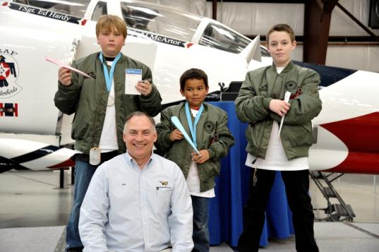

2013 Great Paper Airplane Fly-off winners Tobias Hahn, Nathaniel Reynolds, and Aaron Embry pose in their flight-jacket prizes with Guinness World Record holder Ken Blackburn.

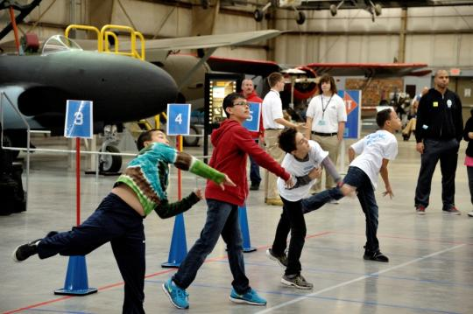

2013 Great Paper Airplane Fly-off heat throwing their paper airplanes

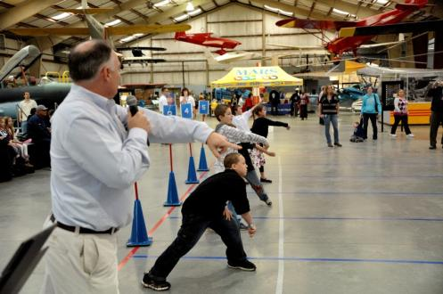

Ken Blackburn signals the start of a heat in the 2013 Great Paper Airplane Fly-off

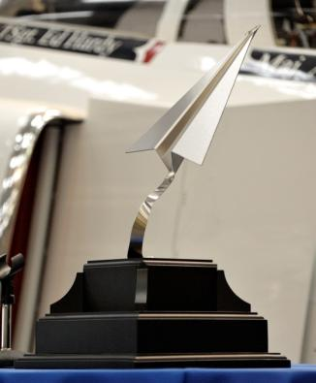

The Great Paper Airplane Trophy on permanent display at the Pima Air & Space Museum.

Photos by Balfour Walker

1. Guinness World Record for the longest paper airplane time aloft, 27.6 seconds