[FOR IMMEDIATE RELEASE
Mary E Emich
Director of Marketing, Sales and Visitor Services
Arizona Aerospace Foundation
6000 East Valencia Road
Tucson, AZ  85756
Phone (520) 618-4805
memich@pimaair.org 
](mailto:memich@pimaair.org)

SMITHSONIAN HONORS LOCAL PHOTOGRAPHER

Tucson, AZ–(Mar. 28, 2013).  *Smithsonian Air & Space Magazine* is featuring a photograph by Pima Air & Space Museum’s John Bezosky entitled “Rainbow’s End” as an example of a photo-contest winner,  for its first annual contest. Bezosky’s photo is one of three rotating graphics headlining the contest informational web page*. *Smithsonian A&S* describes the shot: “Photographer John Bezosky assures us that this was the honest-to-goodness sight of an A-10C from the back door of his office at the Pima Air and Space Museum in Tucson, Arizona.” Source: <http://www.airspacemag.com/photocontest/>. The Pima Air & Space Museum currently exhibits an A-10 in its indoor collection (Hangar 1 South). Come take a shot of the A-10 or any of the almost 300 airplanes in our collection for your contest entry. Bezosky is the Collections Registrar at the Pima Air & Space Museum.

**ABOUT THE A-10**

Called the Warthog by its pilots and ground crews, the Fairchild A-10 is not the prettiest aircraft ever built, but it is extremely good at its job -- killing tanks. Designed around a massive 30mm rotary cannon capable of firing up to 4,200 rounds per minute and with large amounts of titanium armor around the cockpit and engines the A-10 is almost a flying tank itself. The A-10 proved its capabilities in the 1990-91 Gulf War by destroying several thousand Iraqi tanks, and other vehicles.

|  |  |
| --- | --- |
| Technical Specifications | |
| **Wingspan** | 57 ft 6 in |
|  |  |
| **Length** | 53 ft 4 in |
|  |  |
| **Height** | 14 ft 8 in |
|  |  |
| **Weight** | 50,000 lbs (loaded |
|  |  |
| **Maximum Speed** | 381 mph |
|  |  |
| **Service Ceiling** | 30,500 ft |
|  |  |
| **Range** | 620 miles |
|  |  |
| **Engines** | 2 General Electric TF34-GE-100 turbofans, 9,065 lbs. thrust |
|  |  |
| **Crew** | 1 |

|  |  |
| --- | --- |
|  |  |

<http://www.pimaair.org/collection-detail.php?cid=97>

**ABOUT PIMA AIR & SPACE MUSEUM**

The Pima Air & Space Museum is one of the largest aviation museums in the world, and the largest non-government funded aviation museum in the United States. The museum, which opened in 1976, maintains a collection of more than 300 aircraft and spacecraft from around the globe, including many rare and one-of-a-kind, and more than 125,000 artifacts. Exhibits at the museum include some of the world’s greatest aviation heritage, including military, commercial, and civil aviation. Among them are a B-29 Superfortress, the SR-71 Blackbird, and a rare World War II German V-1 "buzz bomb." The museum has five large hangars totaling more than 177,000 indoor feet—almost four football fields­—of exhibit space. In addition, the 390th Bombardment Group (Heavy) Memorial Museum is located on the museum grounds. Pima Air & Space maintains its own aircraft restoration center, and also offers exclusive tours of the Aerospace Maintenance and Regeneration Group (AMARG), also known as the "Bone Yard" (across the street at Davis-Monthan Air Force Base). Open daily except Thanksgiving and Christmas, PASM is located at 6000 E. Valencia Rd. in Tucson; more information about the museum can be found at [www.pimaair.org](http://www.pimaair.org/), on Facebook, or at 520-574-0462.

###

Attachment: Photograph by John Bezosky, PASMRainbowsEndPhotoJBezosky.jpg

*You may need to use Firefox as your browser to see the rotating graphics.

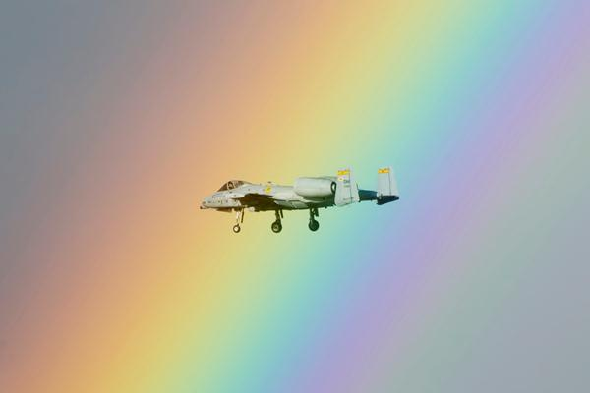

Figure 1 "Rainbow's End" by John Bezosky PASM