[FOR IMMEDIATE RELEASE
Mary E Emich
Director of Marketing, Sales and Visitor Services
Arizona Aerospace Foundation
6000 East Valencia Road
Tucson, AZ  85756
Phone (520) 618-4805
memich@pimaair.org 
](mailto:memich@pimaair.org)                                             

TITAN MISSILE MUSEUM COMMEMORATES 50 YEARS OF THE BANG THAT NEVER WAS!

Sahuarita, AZ – Jun. 28, 2013. The Titan Missile Museum announced commemorative celebrations marking 50 years since the actual Titan II site, 571-7, went operational on Jul. 15, 1963. Celebrations include:

* an extra-special Moonlight MADness  on Sat. evening, Jul. 13, during which you can win a chance to sound the alarm! (Reservations required, call 625-7736).
* an official Pima County proclamation,
* special tours on Mon., Jul. 15th by past commanders,
* FREE Titan Missile Museum admission for anyone born during July, 1963—the same month and year the site went operational—from Jul 15, 2013 through Aug. 31, 2013! (ID required).

The extra-special Moonlight MADness/cool summer evening event (Sat., Jul 13, 5 to 9pm, cost $7/adult, kids 12 & Under FREE) features:

* Professional chalk artists and community “chalking” on the massive 760-ton silo door
  + Chris Leon
  + Jamie Tooley
  + Matt Cotten
  + Greg Ewald
* Expanded viewing sites for the missile, lit up!
* The Thunderbolt siren (that once signaled evacuation) being set off by community members
  + The 6pm siren “pulled” by the winner of a Facebook contest (enter by 7/1/13 at <https://www.facebook.com/pages/The-Titan-Missile-Museum/225757590289?fref=ts>)
  + 6:30, 7, 7:30 and 8pm sirens to be set off by onsite drawing winners (among other prizes)
* Southern Arizona Rocketry Assn. and Raytheon displays and plus activities for kids including “MAD” scientist seltzer rockets
* The Flight Grill Food Truck (from the Pima Air & Space Museum) serving a special family-centric “grab ‘n go’ menu
* Book signing by Titan Archivist and Historian Chuck Penson
* No fireworks (remember, this is the bang that wasn’t)
* Reservations at 625-7736.

“Thank goodness none of the Titan II missiles were ever launched from the U.S. so we can celebrate the success of the historic strategy that deterred our enemies; and commemorate 50 years since it went operational,” commented Yvonne Morris, a past Titan II missile silo commander and now Executive Director of the Arizona Aerospace Foundation (that operates the Titan Missile Museum). “I especially recommend coming to chalk on the massive silo doors, and see the masterpieces the professionals create inspired by the program,” continued Morris, “fifty years later, it’s continuing to execute its mission through education.” For a detailed history of the development of rocketry and the missile program see the attached article by Titan Missile Museum Archivist and Historian Chuck Penson entitled “Deterrence and the Ultimate Weapon.” Special commemorative coins will be available for purchase.

**ABOUT THE TITAN MISSILE MUSEUM**

The Titan Missile Museum is the only remaining Titan II site, open to the public, allowing you to relive a time when the threat of nuclear war between the U.S. and the former Soviet Union was a reality. The Titan II was capable of launching from its underground silo in 58 seconds and could deliver a nine megaton thermonuclear warhead to its target more than 5,500 miles away in less than thirty minutes. For more than two decades, 54 Titan II missile complexes across the United States stood "on alert" 24 hours a day, seven days a week, heightening the threat of nuclear war or preventing Armageddon, depending upon your point of view. To visit the Titan Museum, take I-19 to exit 69 Duval Mine Road west in Sahuarita, AZ. Open daily 8:45am to 5pm, except Thanksgiving and Christmas. Tours on the hour. More information can be found at [www.titanmissilemuseum.org](http://www.titanmissilemuseum.org) or by calling 520 625-7736. Yvonne Morris is available for interviews.

###

Attachments: titan2launch.jpg; TMM571-7 now color.jpg; TMM571-7 then.jpg

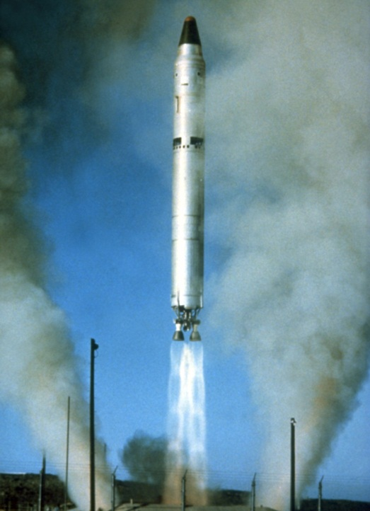

Test launch of a Titan II Intercontinental Ballistic Missile from Vandenberg Air Force Base

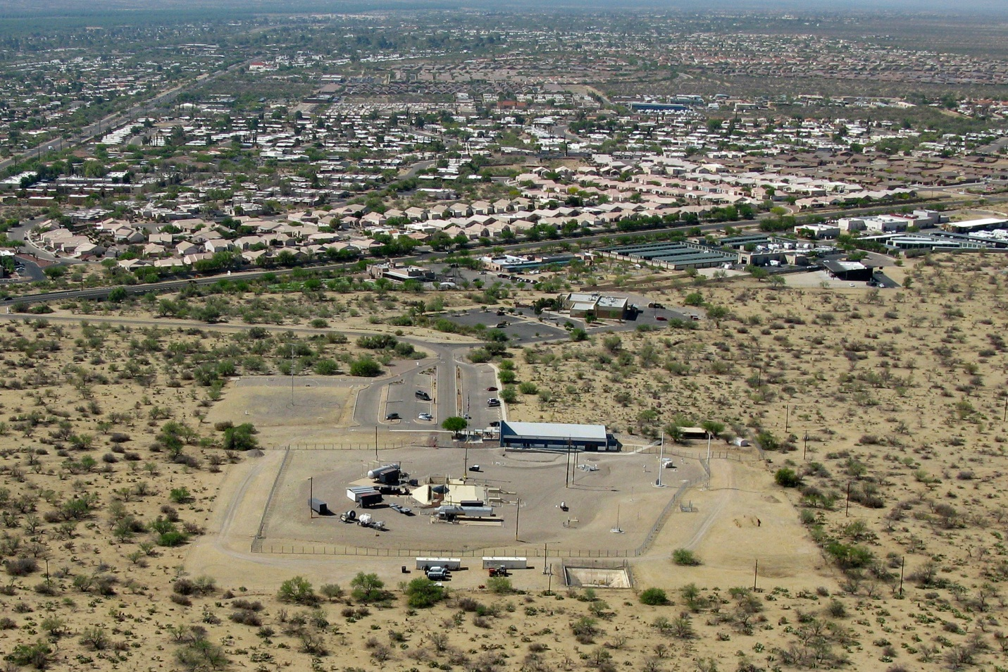

Missile site 571-7 as it appears today. By 1980, civilization had encroached significantly on the complex, causing much concern among Air Force officials. Photgrpahy by Chuck Penson and pilot Bert Zaccaria

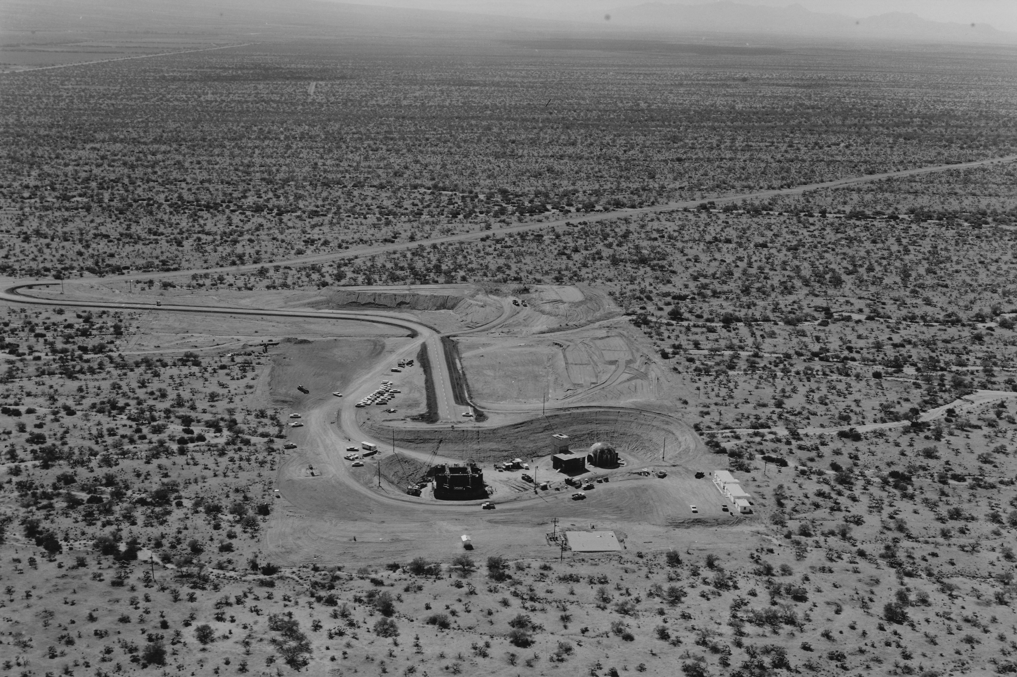

Missile site 571-7 under construction in 1962. The silo cover is seen at the left side of excavation, with the blast lock and control center to the right.