[FOR IMMEDIATE RELEASE
Mary E Emich
Director of Marketing, Sales and Visitor Services
Arizona Aerospace Foundation
6000 East Valencia Road
Tucson, AZ  85756
Phone (520) 618-4805
memich@pimaair.org 
](mailto:memich@pimaair.org)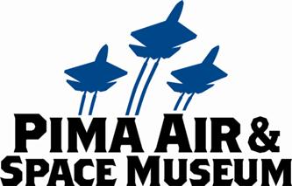

SALUTING ACTIVE-DUTY SERVICE PERSONNEL: PIMA AIR & SPACE MUSEUM OFFERING FREE ADMISSION TO ACTIVE-DUTY MILITARY & THEIR FAMILIES ON JULY 4TH

Tucson, AZ—Jun. 28, 2013. Pima Air & Space Museum announced FREE admission for active military, their spouses and dependents this Independence Day (Thu., Jul. 4, 2013). The museum would like to thank our active military for their service during these tough financial times by offering FREE admission [during normal business hours 9 AM to 5 PM (last admission 4 PM)] for one day only, July 4,2013. Military ID is required for admission.

“We are happy to offer a little perk to our military especially in light of recent cutbacks for the July 4th holiday,” stated Yvonne Morris, Executive Director of the not-for-profit Arizona Aerospace Foundation that operates Pima Air & Space. She continued, “It’s always heartwarming to watch the enthusiasm as parents share their knowledge of our collection with their kids.”

Pima Air & Space’s onsite restaurant, Flight Grill, will be open as usual. The docent-narrated tram tour ($6pp) facilitates experiencing the amazing outdoor aircrafts over the museum’s 80 acres. Due to the holiday, the “Boneyard”/AMARG tours will not be available. Pima Air & Space Museum traditionally offers free admission for active-duty military on Veterans Day and Memorial Day, however this is a one-time offer for July 4th-- only for 2013.

**ABOUT PIMA AIR & SPACE MUSEUM**

Be wowed at Pima Air & Space Museum! Pima Air & Space is one of the largest aviation museums in the world, and the largest non-government-funded aviation museum in the U.S. The museum maintains a collection of more than 300 aircraft and spacecraft from around the globe with 125,000+ artifacts. Exhibits at the museum include some of the world’s greatest aviation heritage, including commercial, military and civil aviation. Among them are the SR-71 Blackbird (the world’s fastest spy plane), a B-29 Superfortress (the WWII bomber that flew higher, farther and faster and carried more bombs), the world’s smallest flying bi-plane, a moon rock and planes used as canvases by renown contemporary artists including Brazilian graffiti artist Nunca. The museum has five large hangars totaling more than 177,000 indoor square feet—almost four football fields­—of air/space craft, heroes’ stories and scientific phenomena. Pima Air & Space maintains its own aircraft restoration center. The Museum also operates exclusive tours of the “Boneyard,” aka the 309th Aerospace Maintenance and Regeneration Group (AMARG), on the Davis-Monthan Air Force Base grounds plus a docent-led tram tour of its 80 acres of airplanes (additional fees apply). Pima Air & Space Museum is located at 6000 E. Valencia Rd. in Tucson. More information about the museum can be found at [www.pimaair.org](http://www.pimaair.org/), on Facebook, or by calling 520 574-0462.

Note: The 390th Bombardment Group (Heavy) Memorial Museum is closed for reconstruction until further notice.

###

Attachment: Staff photos: PASMWWIIB-29.jpg; PASMDadHueyDaughterReflection.jpg

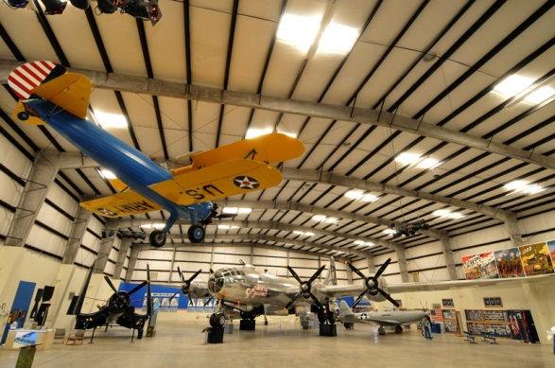

WWII B-29

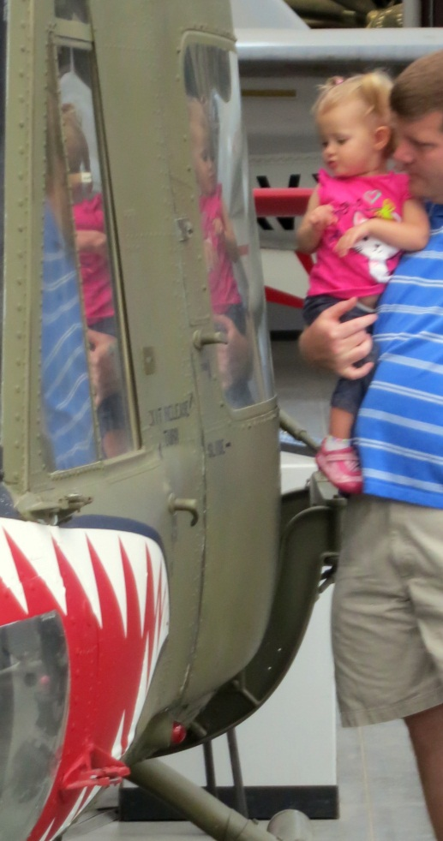

Father & Daughter looking at reflection in Huey