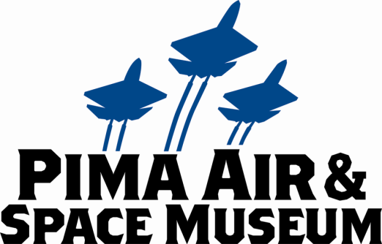

**FOR IMMEDIATE RELEASE**

Mary E Emich  
Director of Marketing, Sales and Visitor Services  
Arizona Aerospace Foundation  
6000 East Valencia Rd  
Tucson, AZ 85756  
Phone (520) 618-4805  
[memich@pimaair.org](mailto:memich@pimaair.org)

# THE PIMA AIR & SPACE MUSEUM RANKS IN THE TOP 10% WORLDWIDE OF EXCELLENT ATTRACTIONS... AGAIN!

# Tucson, AZ–Jul. 20, 2013.  TripAdvisor has awarded the Pima Air & Space Museum the Top 10% IN THE WORLD Certificate of Excellence for the second year in a row. The certificate recognizes the top-performing businesses on TripAdvisor, and is only awarded to businesses that rank in the top 10% worldwide for traveler feedback aka excellent ratings. The Pima Air & Space Museum/Arizona Aerospace Foundation also earned the Certificate of Excellence in 2012.

# “We are honored to receive this distinction,” stated Yvonne Morris, Executive Director of the not-for-profit Arizona Aerospace Foundation that operates Pima Air & Space. She continued, “We are proud to provide our visitors with great experiences thanks to our hard-working, dedicated staff and volunteers. This award is as much theirs as it is ours.”

The consistently great feedback the Pima Air & Space Museum has received on TripAdvisor for the past two years proves it is a world-class destination. The awesome aircraft and knowledgeable and helpful staff/volunteers are just two reasons why travelers find the museum to be a standout among world-travel destinations.

With the TripAdvisor endorsement, seventy-five percent of surveyed travelers said they were more likely to “visit.” [Source: TripAdvisor Member Survey, October 2012.]

**ABOUT PIMA AIR & SPACE MUSEUM**

Be wowed at Pima Air & Space Museum, one of the largest aviation museums in the world and the largest non-government-funded in the U.S. Its significant collection, 300 strong from around the globe, covers commercial, military and civil aviation alongside more than 125,000+ artifacts, including a moon rock donated by Tucsonan and Astronaut Frank Borman. Be amazed by many all-time great aircraft: the SR-71 Blackbird (the world’s fastest spy plane); a B-29 Superfortress (the WWII bomber that flew higher, farther and faster plus carried more bombs); the world’s smallest bi-plane; the C-54 (the Berlin Airlift’s star flown by the famous “Candy Bomber”  Col. USAF (Ret.) Gail Halvorsen, a Tucson-area winter resident); plus planes used as renowned-contemporary-artists’ canvases, including Brazilian graffiti artist Nunca. Explore five large hangars totaling more than 177,000 indoor square feet—almost four football fields­—of air/space craft, heroes’ stories and scientific phenomena including the largest paper airplane (our work). Two+ hangars are dedicated to WWII, one each to the European and Pacific theaters. Pima Air & Space maintains its own aircraft restoration center. It also operates exclusive tours of the “Boneyard,” aka the 309th Aerospace Maintenance and Regeneration Group (AMARG) on Davis-Monthan Air Force Base, plus offers a docent-led tram tour of its 80 acres (additional fees apply). Pima Air & Space Museum is located at 6000 E. Valencia Rd., just off I-10 exit 267, in Tucson. More information can be found at [www.pimaair.org](http://www.pimaair.org/), on Facebook, <https://www.facebook.com/PimaAirAndSpace>, or by calling 520 574-0462.

Note: The 390th Bombardment Group (Heavy) Memorial Museum is closed for reconstruction until further notice.

                                      ###

Attachment: PASMTripAdvisor2013Top10PercentAward.pdf;

PASMDocentKenHollettMariner.jpg = Docent Ken Hollett informing a tour on the PBM-5A Martin Mariner, one of only two in existence.

PASMHangar4.jpg=Pima Air & Space Museum’s Asian-theater World War II hangar

PASMDocentKeithConnollyElectra.jpg = docent Keith Connolly holding kids rapt attention in front of the Lockheed Model 10 Electra, the same airplane type that Amelia Earhart flew.

# M:\NewsReleases\TripAdvisor2013\PASMDocentKenHollettMariner.JPG

Docent Ken Hollett informing a tour on the PBM-5A Martin Mariner, one of only two in existence.

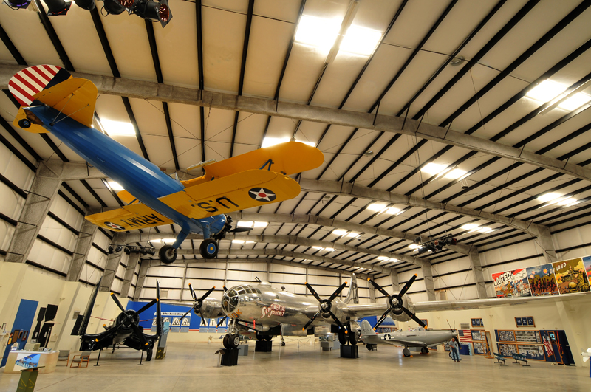

Pima Air & Space Museum’s Asian-theater World War II hangar

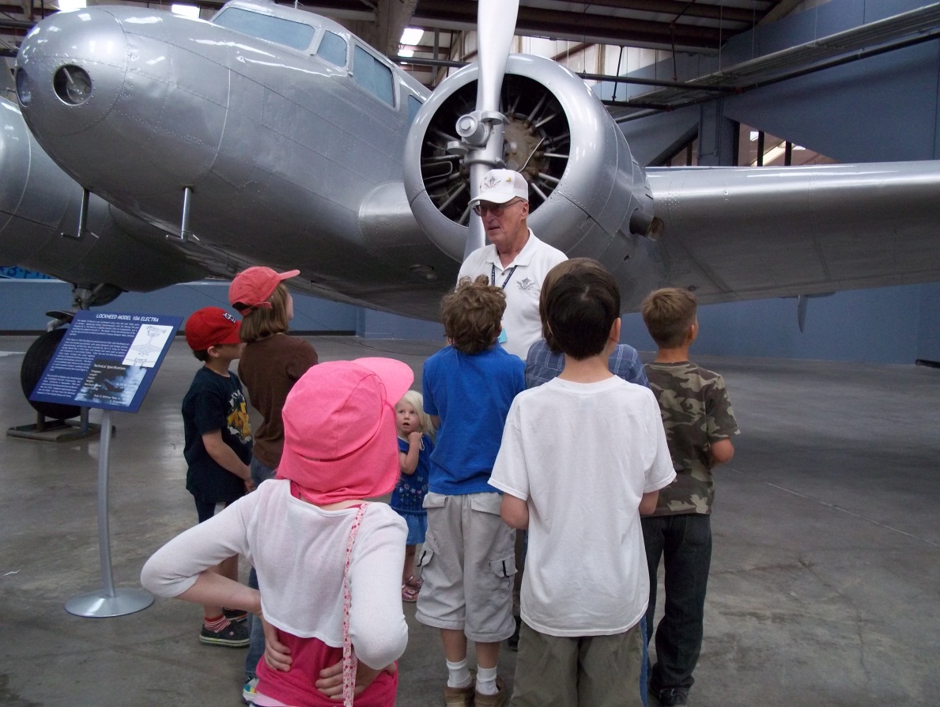

Docent Keith Connolly holding kids rapt attention in front of the Lockheed Model 10 Electra, the same airplane type that Amelia Earhart flew.