

**FOR IMMEDIATE RELEASE**

Mary E Emich  
Director of Marketing, Sales and Visitor Services  
Arizona Aerospace Foundation  
6000 East Valencia Rd  
Tucson, AZ 85756  
Phone (520) 618-4805  
[memich@pimaair.org](mailto:memich@pimaair.org)

# WITH THE BRITISH IMPERIAL WAR MUSEUM, PIMA AIR & SPACE UNVEILS THE “HIND” SOVIET HELICOPTER, THEIR FIRST FOREIGN CHOPPER.

**Tucson, AZ–Aug. 5, 2013.** The Arizona Aerospace Foundation and the Imperial War Museum of England have unveiled a unique, Soviet-design helicopter at the Pima Air & Space Museum: the MIL Mi-24 Hind-D helicopter. The historic helicopter is on permanent loan from the Imperial War Museum. The successful partnership involved conquering the major endeavors of negotiation, dismantling and shipping the Mi-24 Hind helicopter across the world to Tucson, AZ. After reassembly and restoration, the helicopter is currently on display. This “import” is unlike any Western helicopter and is currently the only non-American helicopter in the Pima Air & Space Museum’s collection.

The MIL Mi-24 Hind-D, serial number B4002, was born in the Mil Moscow Helicopter Plant and delivered to the East German Air Force around 1977. Also known as the “Hind,” it served on an East German flying unit that was based at Cottbus Air Base during the reunification of Germany in 1990. The helicopter was taken into service with the reunified German Air Force and given the number 96+21. By 1993, Germany was disposing of most of its Soviet-built aircraft, and the B4002 was donated to the Imperial War Museum in the United Kingdom. It was put on display in Duxford until last year when the museum began collaboration with the Pima Air & Space Museum to bring the helicopter to Tucson. Its current markings are “East German Air Force, 1990.”

“We are pleased to collaborate with the Imperial War Museum and bring this unique aircraft to America,” Scott Marchand, Director of Collections and Restoration, of the Pima Air & Space Museum said. He continued, “This helicopter is unlike any Western helicopter ever built, so it’s an intriguing contrast to the museum’s other helicopters.”

The Hind was built to pull double duty by combining the features of a heavily armed and armored helicopter gunship with the troop carrying capability of a light-assault helicopter. In 1970, production and deployment of the helicopter to Soviet forces began. It was also widely sold to the Soviet Union’s allies. The Hind first saw combat in 1977 in Ethiopia during its war with Somalia. The helicopter gained stardom during the Soviet occupation of Afghanistan during the 1980s. The Hind proved difficult to shoot down, and its combat prowess helped lead the United States into supplying direct military aid to the Afghans. The Hind has managed to survive the dissolution of the Soviet Union and the Warsaw Pact, and is still in service in the Russian military and 30 other countries.

**Technical Specifications:**

Main Rotor Diameter: 56 feet 7 inches

Length: 57 feet 4 inches

Height: 21 feet 3 inches

Weight: 26,500 lb (loaded)

Maximum Speed: 208 mph

Service Ceiling: 14,750 feet

Range: 280 miles

Engines: Two IsotovTV3-117 turbines with 2,200 horse power each

Crew: 2 and 8 troops

**ABOUT PIMA AIR & SPACE MUSEUM**

Be wowed at Pima Air & Space Museum, one of the largest aviation museums in the world and the largest non-government-funded in the U.S. Its significant collection, 300 strong from around the globe, covers commercial, military and civil aviation alongside more than 125,000+ artifacts, including a moon rock donated by Tucsonan and Astronaut Frank Borman. Be amazed by many all-time great aircraft: the SR-71 Blackbird (the world’s fastest spy plane); a B-29 Superfortress (the WWII bomber that flew higher, farther and faster plus carried more bombs); the world’s smallest bi-plane; the C-54 (the Berlin Airlift’s star flown by the famous “Candy Bomber” Col. USAF (Ret.) Gail Halvorsen, a Tucson-area winter resident); plus planes used as renowned-contemporary-artists’ canvases, including Brazilian graffiti artist Nunca. Explore five large hangars totaling more than 177,000 indoor square feet—almost four football fields­—of air/space craft, heroes’ stories and scientific phenomena including the largest paper airplane (our work). Two+ hangars are dedicated to WWII, one each to the European and Pacific theaters. Pima Air & Space even maintains its own aircraft restoration center. The museum also operates exclusive tours of the “Boneyard,” aka the 309th Aerospace Maintenance and Regeneration Group (AMARG) on Davis-Monthan Air Force Base, plus offers a docent-led tram tour of its 80 acres (additional fees apply). Pima Air & Space Museum is located at 6000 E. Valencia Rd., just off I-10 exit 267, in Tucson. More information can be found at [www.pimaair.org](http://www.pimaair.org/), on Facebook [www.facebook.com/PimaAirAndSpace](http://www.facebook.com/PimaAirAndSpace), or by calling 520 574-0462.

Note: The 390th Bombardment Group (Heavy) Memorial Museum is closed for reconstruction until further notice.

###

Attachments: photos by John Bezosky

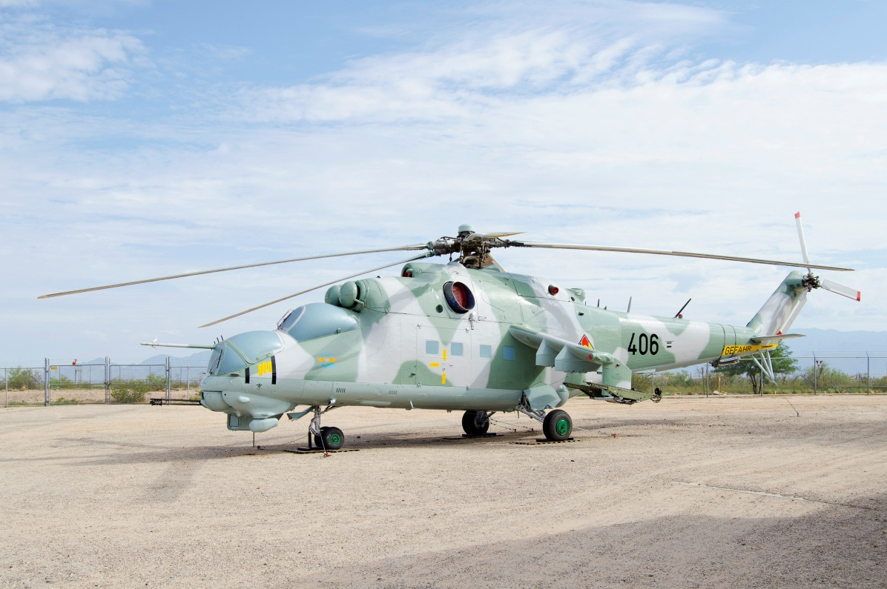

The fully restored MIL Mi-24 Hind-D Helicopter

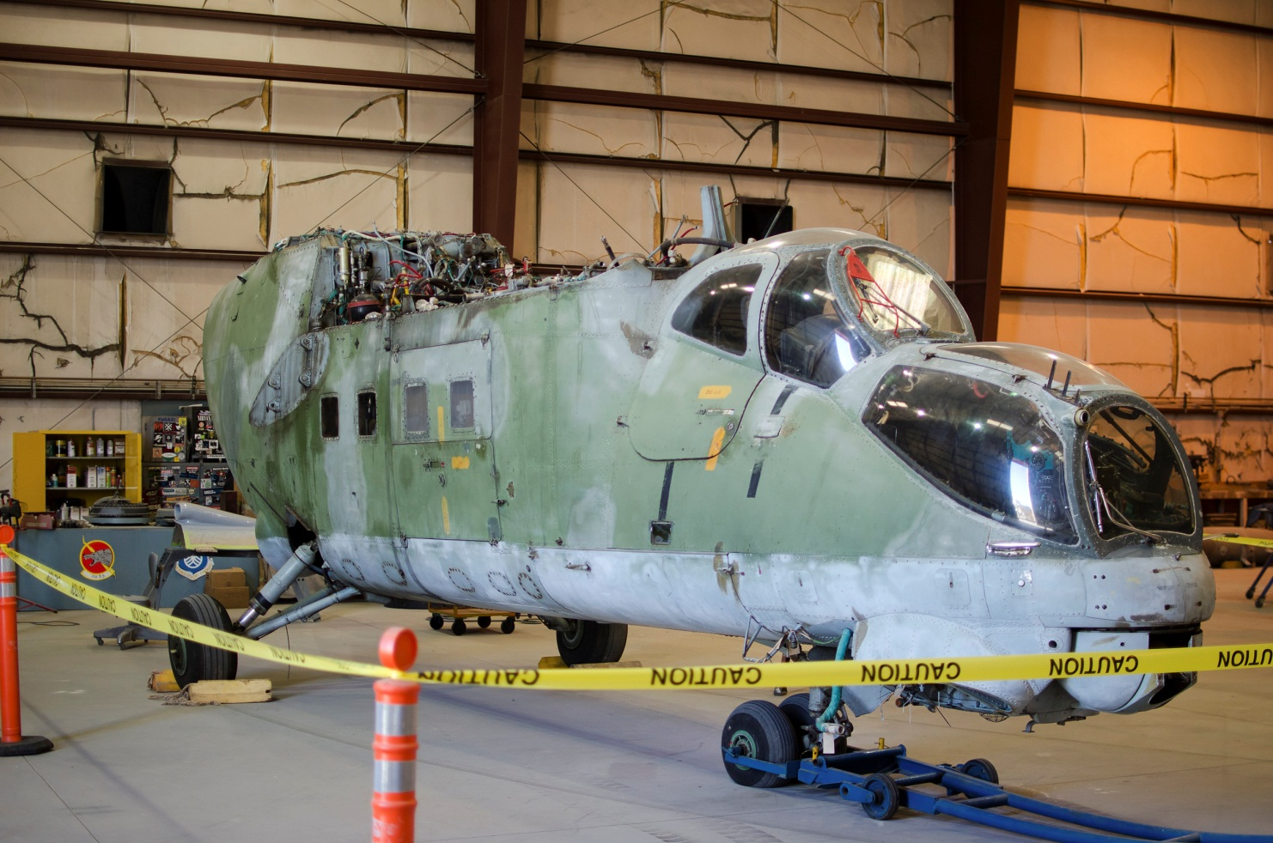

Hind Mi-24 during the restoration process carried out by Pima Air & Space Museum staff and volunteers

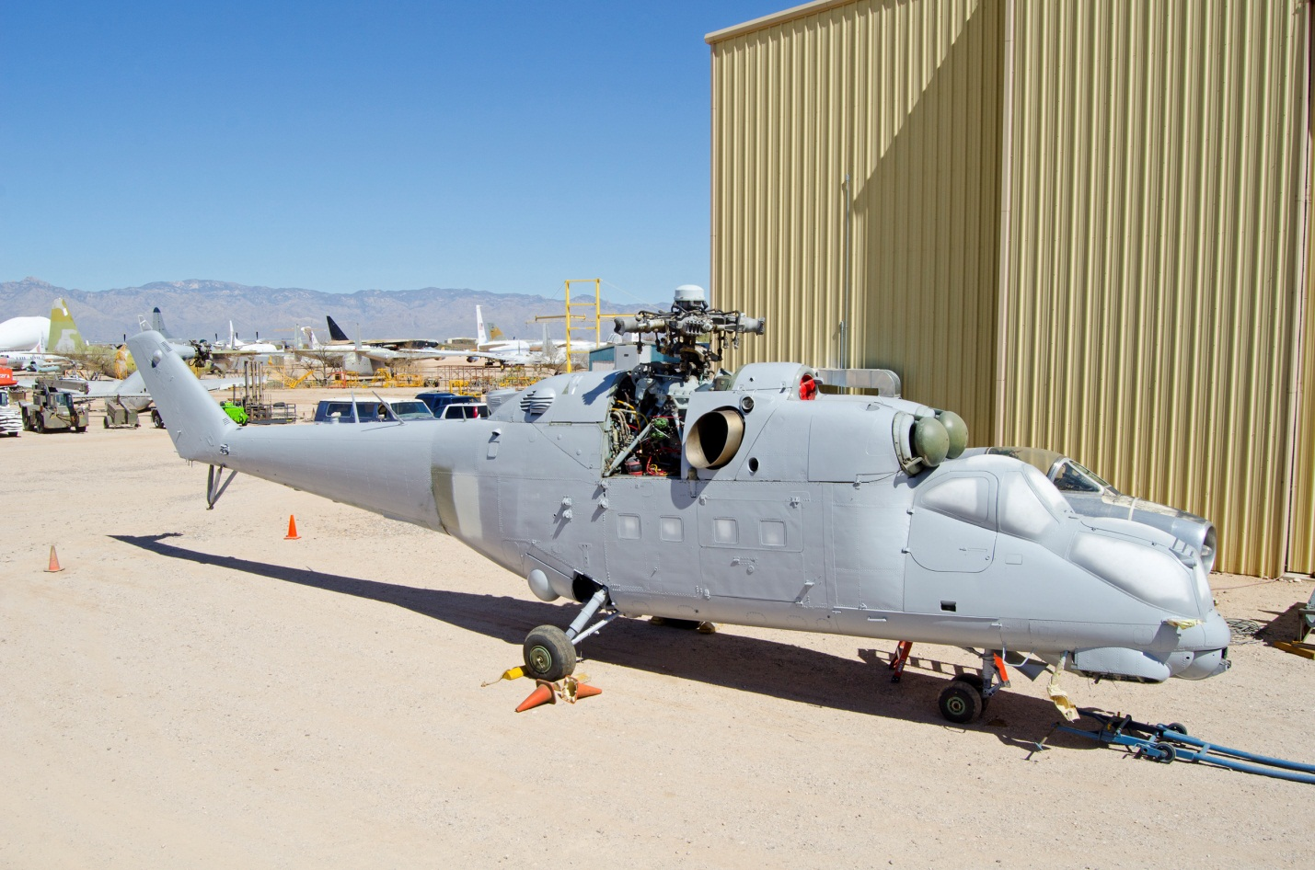

Hind Mi-24 being painted in restoration

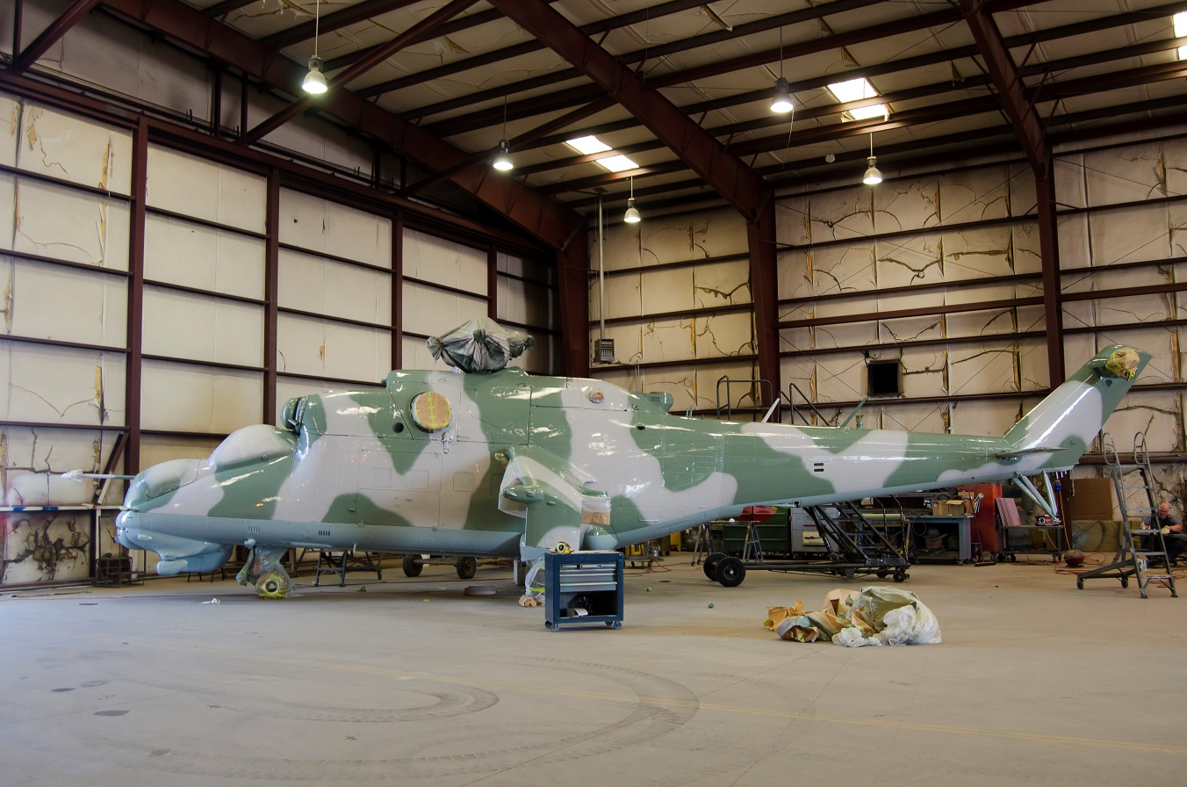

Hind Mi-24 getting a top coat of paint in restoration