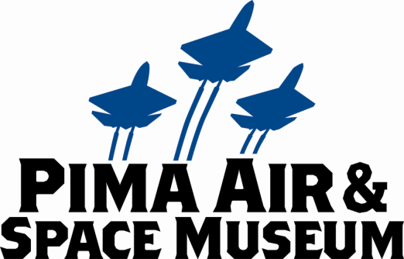

FOR IMMEDIATE RELEASE
Mary E Emich
Director of Marketing, Sales and Visitor Services
Arizona Aerospace Foundation
6000 East Valencia Rd
Tucson, AZ 85756
Phone (520) 618-4805
memich@pimaair.org

PIMA AIR & SPACE MUSEUM ANNOUNCES “FIND THE DISNEY© PLANES’ PLANES” AND PHYSICS FACTORY FOR ITS FINAL “NIGHT WINGS” PROGRAM THIS SUMMER

TUCSON—Aug. 8, 2013. The Pima Air & Space Museum announces “Find The Disney© Planes’ Planes” Scavenger Hunt and the Physics Factory as the special features during its third and final “Night Wings” summer evening program Sat., Aug. 24th, 5 to 9pm.

Pima Air & Space Museum features planes (and vehicles) that inspired 12 of the 14 main characters in the new Disney animated comedy adventure, Planes, including the newly unveiled F-18 Hornet/Blue Angel (Echo and Bravo), the Vought F-4U Corsair (Skipper), a Snow crop duster (Dusty), a Rutan Long-EZ (Ishani), a V-tailed Bonanza (Rochelle), even Dottie and Chug! During Night Wings, kids will be rewarded with stickers when they locate each of the real planes that inspired the characters in the movie. “The movie is amazingly accurate regarding aviation science and milestones,” commented Mina Stafford, Curator of Education, “so bring your kids to see the real planes to maximize their enthusiasm and learning.”

The Physics Factory, an outshoot of the University of Arizona Physics Phun, grabs kids’ (and adults’) attention with huge sparks, invisible forces, smoke, lasers, and other amazing phenomena making physics interesting and fun. Bruce Bayly, PhD, and Physics Factory instructor claims, “We use everyday objects in our hands-on learning stations and mentoring environments, to demystify science and to help students appreciate their amazing world.”

Plus the museum will have 12 other tables of aviation activities: impact craters, sampling space food (ice cream, YUM!), climbing in the cockpit of the Shooting Star high-speed jet trainer (mentioned in the movie), plane spotting, a coloring/drawing contest and prizes too, including a chance to win a free family membership.

These activities are in addition to the museum’s fantastic planes contrasted by the setting sun and inside almost four football fields of hangars. So join us, rain or shine! Adults only $10. Kids 12 & under are FREE. For only $4 more you can ride the tram and breeze around the 150 planes on the grounds (departure at 5:30 and 6:15 pm). Great food—burgers, salads, pizza and ice cream—will be available in The Fight Grill.

ABOUT PIMA AIR & SPACE MUSEUM
Be wowed at Pima Air & Space Museum, one of the largest aviation museums in the world and the largest non-government-funded in the U.S. (TripAdvisor ranks it in the Top 10% worldwide for excellent ratings.) Its significant collection, 300 strong from around the globe, covers commercial, military and civil aviation alongside more than 125,000+ artifacts, including a moon rock donated by Tucsonan and Astronaut Frank Borman. Be amazed by many all-time great aircraft: the SR-71 Blackbird (the world’s fastest spy plane); a B-29 Superfortress (the WWII bomber that flew higher, farther and faster plus carried more bombs); the world’s smallest bi-plane; the C-54 (the Berlin Airlift’s star flown by the famous “Candy Bomber” Col. USAF (Ret.) Gail Halvorsen, a Tucson-area winter resident); plus planes used as renowned-contemporary-artists’ canvases, including Brazilian graffiti artist Nunca. Explore five large hangars totaling more than 177,000 indoor square feet—almost four football fields—of air/space craft, heroes’ stories and scientific phenomena. Two+ hangars are dedicated to WWII, one each to the European and Pacific theaters. Pima Air & Space maintains its own aircraft restoration center. It also operates exclusive tours of the “Boneyard,” aka the 309th Aerospace Maintenance and Regeneration Group (AMARG) on Davis-Monthan Air Force Base, plus offers a docent-led tram tour of its 80 acres (additional fees apply). Pima Air & Space Museum is located at 6000 E. Valencia Rd., just off I-10 exit 267, in Tucson. More information can be found at www.pimaair.org, on Facebook www.facebook.com/PimaAirAndSpace, or by calling 520 574-0462.

# # #

