[FOR IMMEDIATE RELEASE
Mary E Emich
Director of Marketing, Sales and Visitor Services
Arizona Aerospace Foundation
6000 East Valencia Rd
Tucson, AZ  85756
Phone 520 618-4805
memich@pimaair.org 
](mailto:memich@pimaair.org)

# PIMA AIR & SPACE MUSEUM RELOCATES HISTORIC BEACON

Tucson—Oct. 4, 2013. The Pima Air & Space Museum has relocated its Airway Beacon Tower to a prominent position near Valencia Rd. Drivers and car passengers can now see it as they drive by.

“We are delighted to move this fascinating piece of aviation history into a more prominent location for all to see,” stated Yvonne Morris, Executive Director of the Arizona Aerospace Foundation, the not-for-profit that operates the Pima Air & Space Museum. “We are hoping it will become a landmark for the Southeast side of Tucson.”

During the 1920s the United States government created a series of lighted “airways” linking major cities across the country. The lighted Airway Beacons were a substantial navigation aid in an era prior to the development of radio navigation. The effectiveness was limited by visibility and weather conditions. Twenty-four-inch-diameter rotating beacons were mounted on 53-foot (16 m) high towers, and spaced ten miles apart. The spacing was closer in the mountains, and farther apart in the plains. The beacons were five-million candlepower, and rotated 6 times a minute. By 1933 approximately 1,500 airway beacons had been constructed to guide pilots from city to city, covering 18,000 miles from coast to coast. Radio navigation systems began to replace the lights in 1929 but it was not until the 1970s that the last of the beacons were officially turned off. Several actually remain in use by the state of Montana and are used to mark dangerous mountainous terrain. The lights are sometimes called “Lindy Lights” in recognition of Charles Lindbergh’s efforts to promote the system during the 1920s. The light preserved at the Pima Air & Space Museum is believed to have originally been placed at the airport at Douglas, Arizona.

Due to the museum’s proximity to the Davis-Monthan Air Force base and its runway, for safety reasons the beacon’s five-million candlepower light will not be lit.

**ABOUT PIMA AIR & SPACE MUSEUM**

Be wowed at Pima Air & Space Museum, one of the largest aviation museums in the world and the largest non-government-funded in the U.S. (TripAdvisor ranks it in the Top 10% worldwide for excellent ratings.) Its significant collection, 300 strong from around the globe, covers commercial, military and civil aviation alongside more than 125,000+ artifacts, including a moon rock donated by Tucsonan and Astronaut Frank Borman. Be amazed by many all-time great aircraft: the SR-71 Blackbird (the world’s fastest spy plane); a B-29 Superfortress (the WWII bomber that flew higher, farther and faster plus carried more bombs); the world’s smallest bi-plane; the C-54 (the Berlin Airlift’s star flown by the famous “Candy Bomber”  Col. USAF (Ret.) Gail Halvorsen, a Tucson-area winter resident); plus planes used as renowned-contemporary-artists’ canvases, including Brazilian graffiti artist Nunca. Explore five large hangars totaling more than 177,000 indoor square feet—almost four football fields­—of air/space craft, heroes’ stories and scientific phenomena. Two+ hangars are dedicated to WWII, one each to the European and Pacific theaters. Pima Air & Space maintains its own aircraft restoration center. It also operates exclusive tours of the “Boneyard,” aka the 309th Aerospace Maintenance and Regeneration Group (AMARG) on Davis-Monthan Air Force Base, plus offers a docent-led tram tour of its 80 acres (additional fees apply). Pima Air & Space Museum is located at 6000 E. Valencia Rd., just off I-10 exit 267, in Tucson. More information can be found at [www.pimaair.org](http://www.pimaair.org/), on Facebook at [www.facebook.com/PimaAirAndSpace](http://www.facebook.com/PimaAirAndSpace), or by calling 520 574-0462.

###

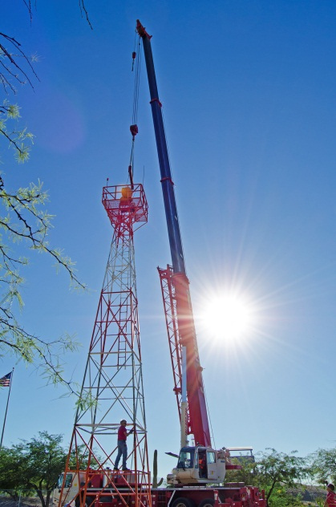

PASMBeaconCrane.jpg = crane moving the beacon to its new location near Valencia Rd. during the early morning. Photo by Andrew Boehly

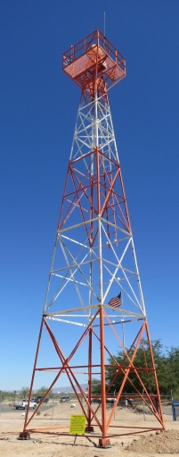 PASMBeacon.jpg = the relocated beacon at Pima Air & Space, photo by mee

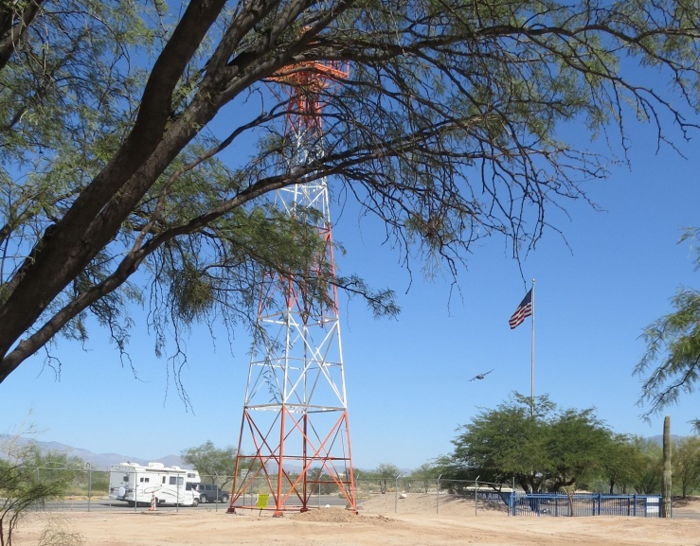

PASMBeaconA-10.jpg = soon after the beacon was relocated, a C-130 takes off from Davis Monthan Air Force Base, photo by mee

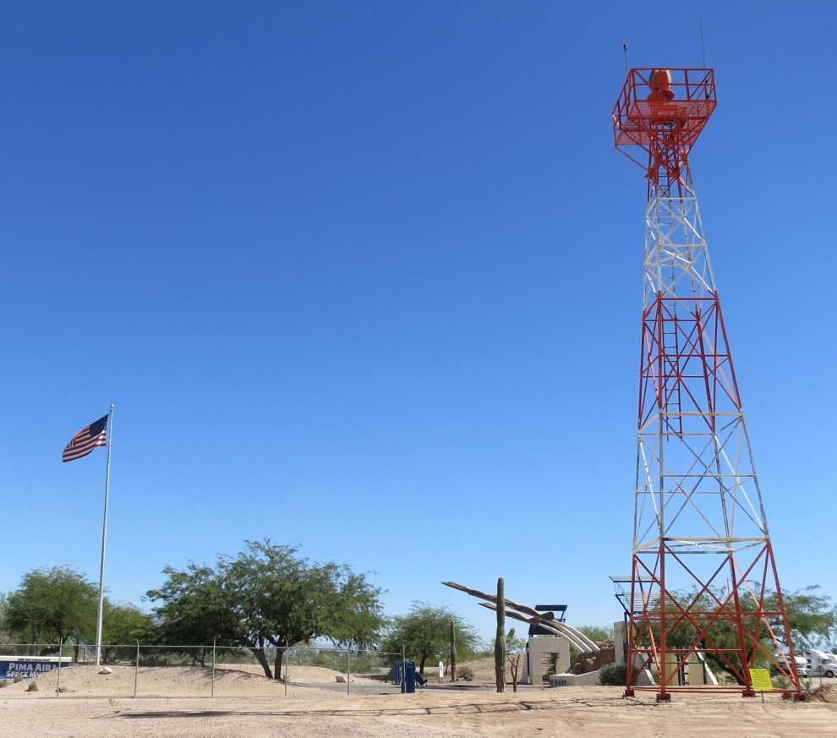

PASMBeaconBeauty.jpg = the relocated beacon at Pima Air & Space and the Museum’s signature entry monument, the Beauty of Flight, photo by mee