[FOR IMMEDIATE RELEASE
Mary E Emich
Director of Marketing, Sales and Visitor Services
Arizona Aerospace Foundation
6000 East Valencia Rd
Tucson, AZ  85756
Phone 520 618-4805
memich@pimaair.org 
](mailto:memich@pimaair.org)

# BOEING TO DEDICATE “WORLD’S-MOST-POPULAR” JET AIRLINER AT PIMA AIR & SPACE MUSEUM

# Tucson, AZ, Oct. 24, 2013—Lou Mancini, Senior Vice President, Commercial Aviation Services, Boeing Commercial Airplanes of The Boeing Company, will dedicate a Boeing 737-300 commercial jet airliner at the Pima Air & Space Museum on Mon., Nov. 4, 2013 at 12:00 noon. Local city and county dignitaries will attend the ceremony for the aircraft which was operated by China Southern Airlines.

“We are extremely grateful to The Boeing Company for helping us acquire this popular airplane. We have great plans not only for its display but also for education, especially with school children,” said Count Ferdinand von Galen, Chairman of the Museum Board of Trustees. He continued, “We are hopeful that this experience will lead to further opportunities to work with Boeing.”

“Boeing is proud to partner with the Pima Air & Space Museum in its educational mission to preserve and present the history of flight,” stated Mancini. “We hope this airplane helps inspire young minds to think big and excel in science, math and other technology subjects in this growing aerospace-centric community.”

The 737-300 was flown into Davis-Monthan Air Force Base and towed, with the crew inside, across Valencia Road. Video footage of this transfer is available.

The Boeing 737 is the most popular jetliner family in the world with more than 7,700 built and another 3,400 on order as of September 2013. The 737 is in use by large and small airlines around the world. It has been estimated that over 2,000 are flying at any given moment with one taking off or landing every two seconds.

The Museum’s newest addition, the 737-300, is part of the 737 Classic series, the second set of airplanes developed in the family. It was a major redesign of the plane from the first generation, featuring new high-bypass turbofan engines that reduced both noise and fuel consumption. The -300 was announced in 1981 and went into airline service with Southwest Airlines and USAir in 1984. A total of 1,113 of this version were built between 1984 and 1999. Brand new, this type of airplane had a list price in the range of $20 to $30 million dollars in the early 1990s.

In addition to the commercial versions of the aircraft the U.S. military has used several versions of the aircraft – including the T-43A, a U.S. Air Force navigation trainer and transport, and the C-40, a cargo and personnel transport in use with the U.S. Navy and Air Force. The latest 737-derived military aircraft is the P-8 Poseidon maritime patrol and anti-submarine warfare aircraft.

**Airplane Service History**

Built by Boeing Aircraft Company at Renton, Washington and delivered on September 23, 1993.

1993-2012                            Operated by China Southern Airlines, People’s Republic of China  
2012                                      Retired from use and returned to Boeing Aircraft Company  
December 2012                  Donated to Pima Air & Space Museum by Boeing

# Technical Data

Wingspan:                           94 feet 9 inches  
Length:                                 109 feet 7 inches  
Height:                                 36 feet 6 inches  
Maximum weight:           124,500 pounds  
Maximum speed:            544 mph  
Maximum Range:            2,685 miles  
Service ceiling:                    37,000 feet  
Engine:                                 Two CFM56-3 high bypass turbofan engines with 23,500 pounds of thrust each

Crew/passengers: 2 flight crew, 4-5 flight attendants, 121-149 passengers

**ABOUT PIMA AIR & SPACE MUSEUM**

Be wowed at Pima Air & Space Museum, one of the largest aviation museums in the world and the largest non-government-funded in the U.S. (TripAdvisor ranks it in the Top 10% worldwide for excellent ratings.) Its significant collection, 300 strong from around the globe, covers commercial, military and civil aviation alongside more than 125,000+ artifacts, including a moon rock donated by Tucsonan and Astronaut Frank Borman. Be amazed by many all-time great aircraft: the SR-71 Blackbird (the world’s fastest spy plane); a B-29 Superfortress (the WWII bomber that flew higher, farther and faster plus carried more bombs); the world’s smallest bi-plane; the C-54 (the Berlin Airlift’s star flown by the famous “Candy Bomber” Col. USAF (Ret.) Gail Halvorsen, a Tucson-area winter resident); plus planes used as renowned-contemporary-artists’ canvases, including Brazilian graffiti artist Nunca. Explore five large hangars totaling more than 189,000 indoor square feet—4+ football fields­—of air/space craft, heroes’ stories and scientific phenomena. Two+ hangars are dedicated to WW II, one each to the European and Pacific theaters. Pima Air & Space maintains its own aircraft restoration center. It also operates exclusive tours of the “Boneyard,” aka the 309th Aerospace Maintenance and Regeneration Group (AMARG) on Davis-Monthan Air Force Base, plus offers a docent-led tram tour of its 80 acres (additional fees apply). Pima Air & Space Museum is located at 6000 E. Valencia Rd., just off I-19 exit 267, in Tucson. More information can be found at [www.pimaair.org](http://www.pimaair.org/), on Facebook at [www.facebook.com/PimaAirAndSpace](http://www.facebook.com/PimaAirAndSpace), or by calling 520 574-0462.

**ABOUT THE BOEING COMPANY**

The Boeing Company is the world's leading aerospace company, with its heritage mirroring the history of flight. It is the largest manufacturer of satellites, commercial jetliners, and military aircraft. In terms of sales, Boeing is the largest U.S. exporter. Total company revenues for 2012 were $81.7 billion.

The Chicago-based company has customers in 150 countries and employees in more than 70 countries. Worldwide, Boeing and its subsidiaries employ nearly 170,000 people, including more than 140,000 with college degrees and nearly 35,000 with advanced degrees that cover virtually every business and technical field.

Boeing Commercial Airplanes provides the world’s leading family of jetliners – the most efficient, reliable and comfortable airplanes from 100 through 465 passengers, designed and sized to enhance airline profitability.

**ABOUT CHINA SOUTHERN AIRLINES**

The largest airline in The People's Republic of China for the past 34 years, China Southern Airlines (CZ) in 2012 reached a passenger volume of over 86.5 million, thereby leading the Chinese aviation industry as the only Chinese carrier entering into the world's Top 10 passenger airlines. With a fleet of 512 modern aircraft and serving 193 cities in 35 countries & regions worldwide, CZ has manifested its leadership in the aviation industry. By July 2013, CZ has kept a safety record of 11.41 million flying hours and 230 months of aviation safety. CZ has hereby retained the best safety record in Chinese aviation and therefore honored with the Diamond Flight Safety Award by the CAAC (Civil Aviation Administration of China).

###

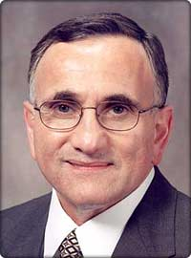 mancini_n.jpg = Lou Mancini, Senior Vice President, Commercial Aviation Services, Boeing Commercial Airplanes of The Boeing Company. Photo courtesy The Boeing Company.

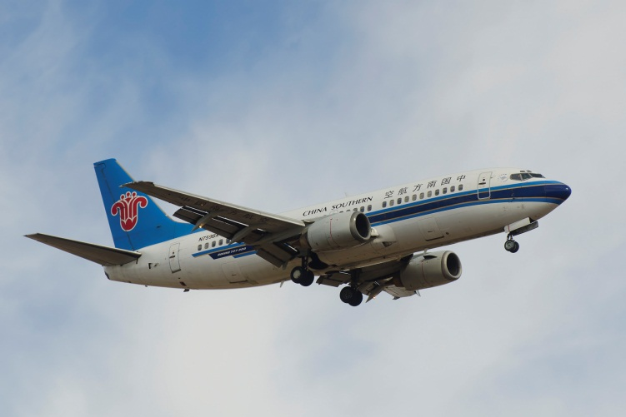

The Boeing 737-300 flying into Davis-Monthan Air Force Base. Photo by John Bezosky.

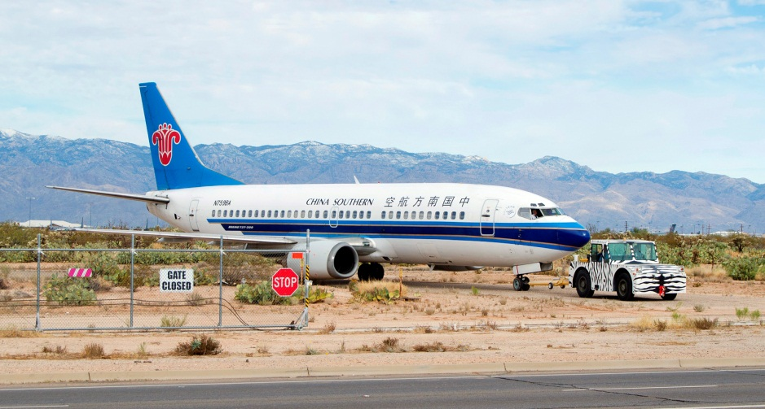

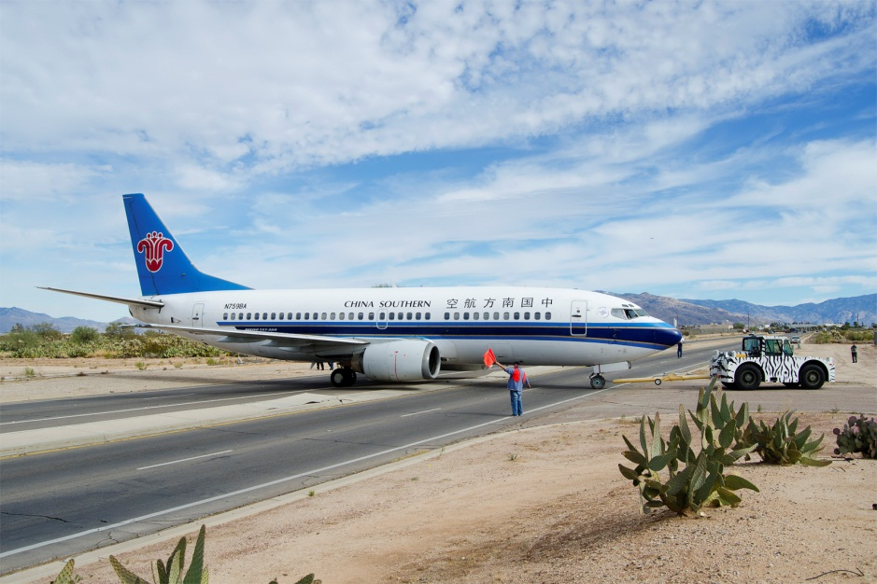

The Boeing 737-300 being towed over from Davis-Monthan Air Force Base to the Pima Air & Space Museum. Photos by John Bezosky

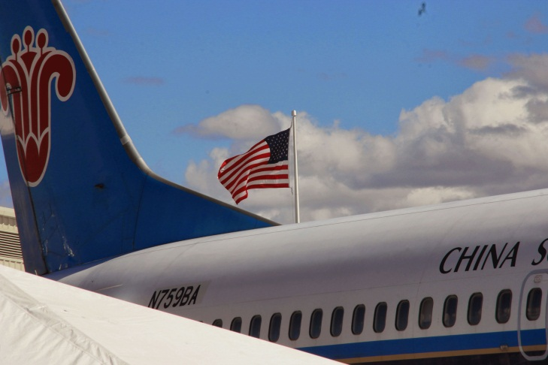

The Boeing 737-300 painted in China Southern Airlines colors at Pima Air & Space Museum near the American colors. Photo by John Saunders.

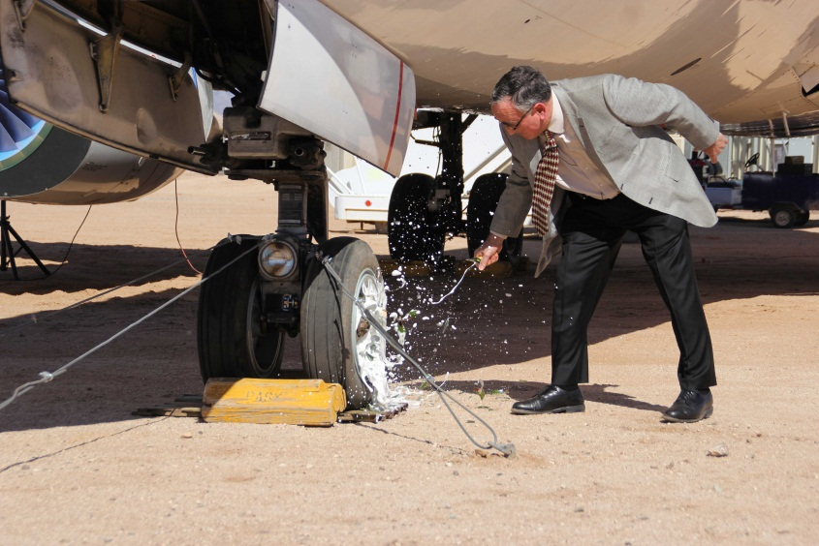

Lou Mancini, Senior Vice President, Commercial Aviation Services, Boeing Commercial Airplanes of The Boeing Company dedicates the Boeing 737-300 at Pima Air & Space Museum. Photo by John Saunders.

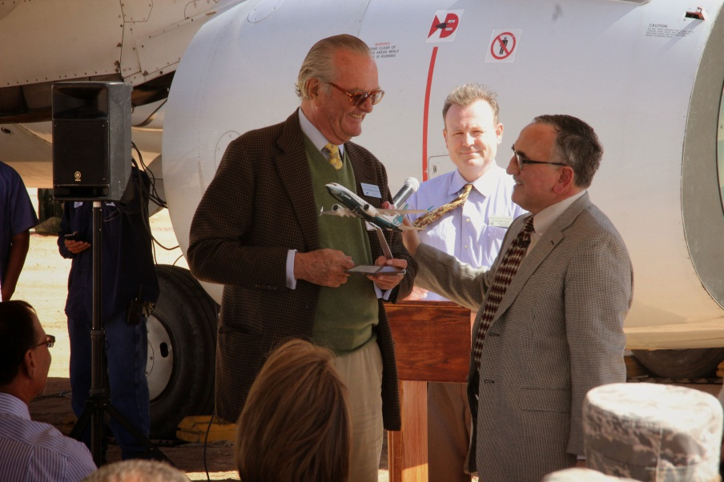

Count Ferdinand von Galen Board Chairman of the Arizona Aerospace Foundation that operates the Pima Air & Space Museum accepts a model from Lou Mancini, Senior Vice President, Commercial Aviation Services, Boeing Commercial Airplanes of The Boeing Company as Pima Air & Space Museum Director of Collections & Restoration, Scott Marchand look on. Photo by John Saunders.