[FOR IMMEDIATE RELEASE
Mary E Emich
Director of Marketing, Sales and Visitor Services
Arizona Aerospace Foundation
6000 East Valencia Rd
Tucson, AZ  85756
Phone 520 618-4805
memich@pimaair.org 
](mailto:memich@pimaair.org)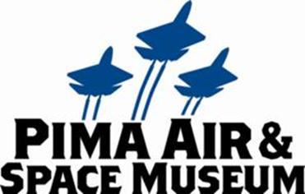

Tucson, AZ Dec. 4, 2013—The Pima Air & Space Museum is pleased to announce the unveiling of a Lockheed Jetstar used as a canvas by contemporary artist Kenny Scharf, entitled “Back To Supersonica.” “Back to Supersonica” joins two other “Round Trip: Art from the Bone Yard Project” painted planes—a C-45 painted by Faile and a VC-140 painted by Andrew Schoultz—originally introduced on January 28, 2012, now prominently displayed on the museum grounds along Valencia Road near the museum’s entrance.

“Traditionally our aircraft along Valencia Road face into the museum (nose in, tails out) to facilitate the docent-guided tram tour of the aircraft and maximize our museum visitor’s experience,” explained Yvonne Morris, Executive Director of the Arizona Aerospace Foundation that operates the Pima Air & Space Museum. Morris continued, “Since the trams can’t operate in this area of our grounds, we placed the smiling faces of the art planes towards passers-by on Valencia to greet everyone and welcome you to the museum.”

Conceived in spring 2010 by gallery owner Eric Firestone, and organized with curator Carlo McCormick, the “Bone Yard Project” resurrects disused airplanes and parts from America’s military history through the creative intervention of contemporary artists, taking entire airplanes and their elements out of Tucson’s scrap yards in the desert, known as “boneyards,” and putting them into the hands of artists. It was in the desert surrounding Pima Air & Space Museum where both Firestone and McCormick first discovered the “boneyards” housing these once mighty metal giants of the United States Air Force. With a nod to the airplane graffiti and “nose art‟ that became popular during WWII, the project offers a vision of the wonder by which humanity takes to the air through some of the most prominent and acclaimed artists working today.

The first phase of the “Bone Yard Project,” “Nose Job,” made its debut in the summer of 2011 with an exhibition of nose cones taken from military airplanes and given to artists to use as eccentric-shaped “canvases” at Eric Firestone Gallery in East Hampton, Long Island. Including more than two dozen artists, “Nose Job” enjoyed critical success as the work tapped into both the broader cultural resonance of this history, and the very personal ways one relates to such a narrative.

Phase Two, “Round Trip: Selections from The Bone Yard Project,” featured five “monumental” works created on military planes by a dynamic selection of popular graffiti and street artists from around the world. It also included selections from the previous “Nose Job” exhibition along with more than a dozen cones interpreted by artists new to this project. The curatorial team included Med Sobio, an independent curator and consultant on graffiti art, and Lesley Oliver of the Scottsdale Museum of Contemporary Art, a longstanding figure on the Arizona art scene. More than 30 artists have participated in “Round Trip” including DC Super 3 planes painted by graffiti artists How & Nosm, Nunca, and Retna. These three planes are also on display at the Pima Air & Space Museum (visitors should go through Hangar 4). The nose-cone art and the C97 cockpit by Saner are not currently on display. The spray-painted “Back to Supersonica,” is an addition to Phase Two.

**ABOUT PIMA AIR & SPACE MUSEUM**

Be wowed at Pima Air & Space Museum, one of the largest aviation museums in the world and the largest non-government-funded in the U.S. (TripAdvisor ranks it in the Top 10% worldwide for excellent ratings.) Its significant collection, 300 strong from around the globe, covers commercial, military and civil aviation alongside more than 125,000+ artifacts, including a moon rock donated by Tucsonan and Astronaut Frank Borman. Be amazed by many all-time great aircraft: the SR-71 Blackbird (the world’s fastest spy plane); a B-29 Superfortress (the WWII bomber that flew higher, farther and faster plus carried more bombs); the world’s smallest bi-plane; the C-54 (the Berlin Airlift’s star flown by the famous “Candy Bomber” Col. USAF (Ret.) Gail Halvorsen, a Tucson-area winter resident); plus planes used as renowned-contemporary-artists’ canvases, including Brazilian graffiti artist Nunca. Explore five large hangars totaling more than 189,000 indoor square feet—four+ football fields­—of air/space craft, heroes’ stories and scientific phenomena. Two+ hangars are dedicated to WWII, one each to the European and Pacific theaters. Pima Air & Space maintains its own aircraft restoration center. It also operates exclusive tours of the “Boneyard,” aka the 309th Aerospace Maintenance and Regeneration Group (AMARG) on Davis-Monthan Air Force Base, plus offers a docent-led tram tour of its 80 acres (additional fees apply). Pima Air & Space Museum is located at 6000 E. Valencia Rd., just off I-10 exit 267, in Tucson. More information can be found at [www.pimaair.org](http://www.pimaair.org/), on Facebook at [www.facebook.com/PimaAirAndSpace](http://www.facebook.com/PimaAirAndSpace), or by calling 520 574-0462.

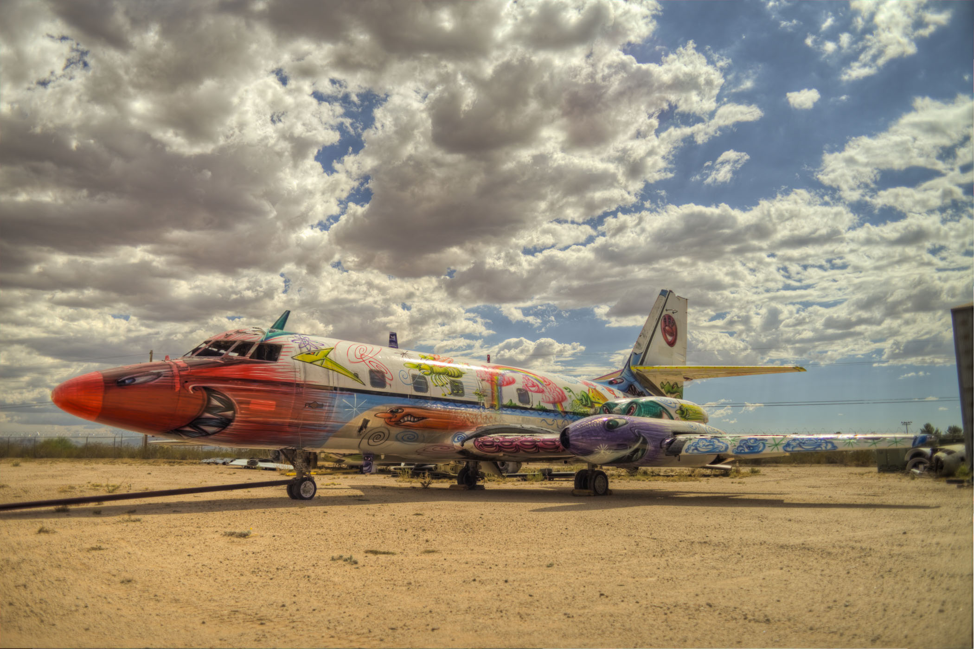

PASMArtPlaneScharf = “Back to Supersonica;” Photo by Jason Wawro

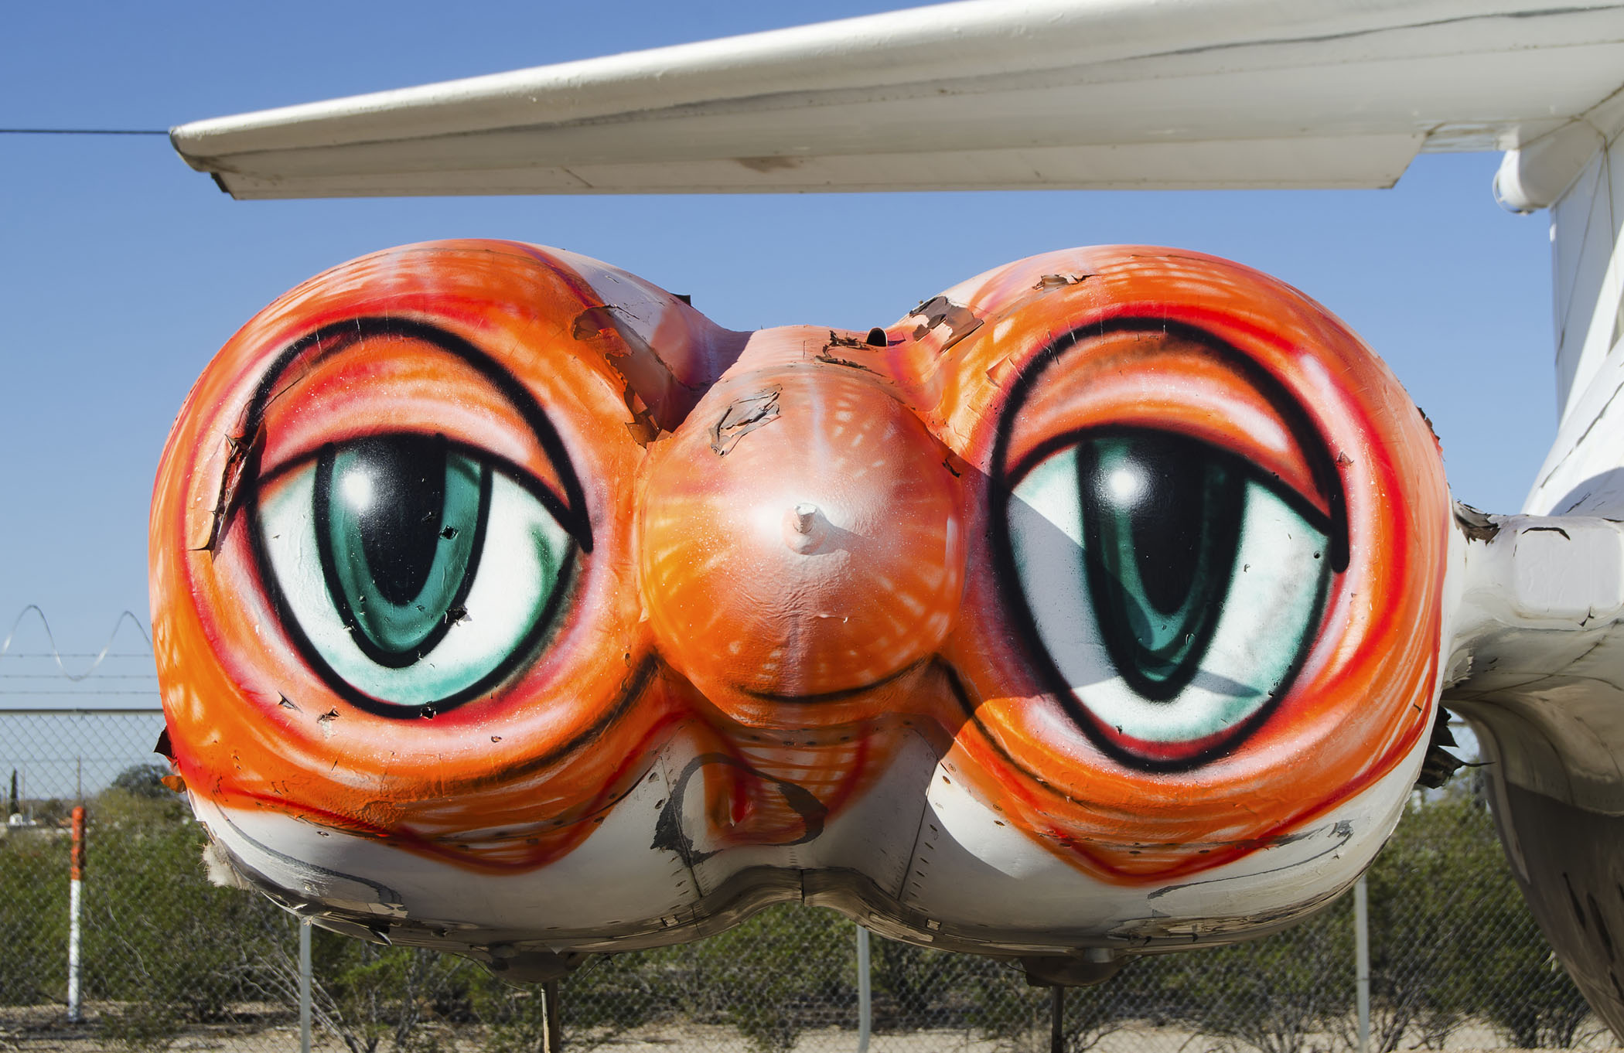

PASMArtPlaneScharfEyes = close up of “Back to Supersonica;” Photo by Jason Wawro

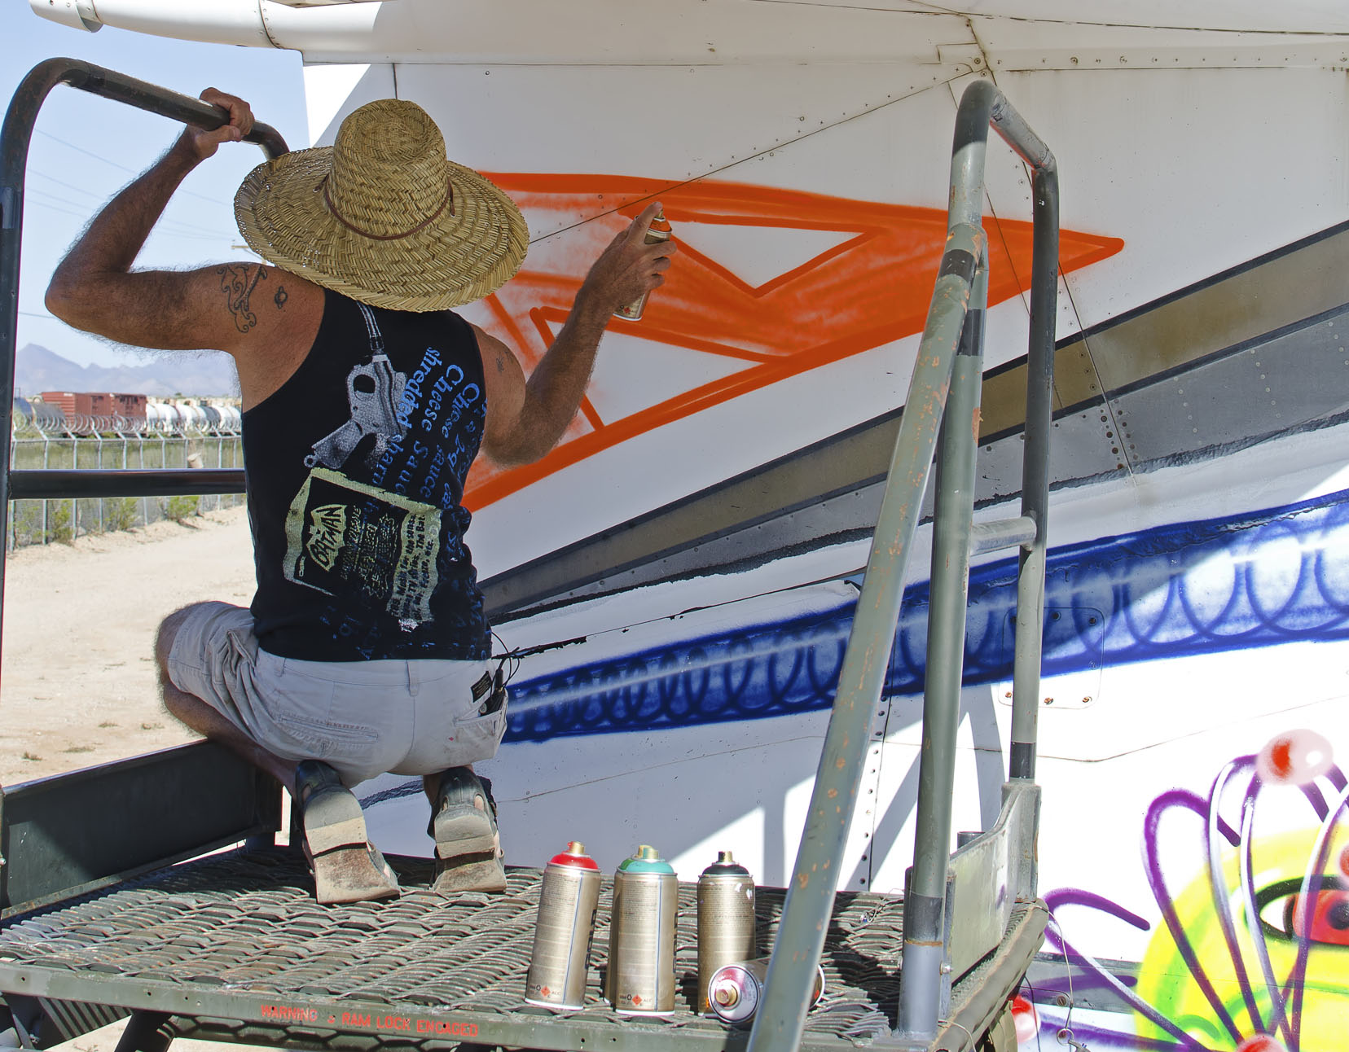

PASMArtPlaneScharfAtWork = Kenny Scharf spray painting “Back to Supersonica” at Pima Air & Space Museum

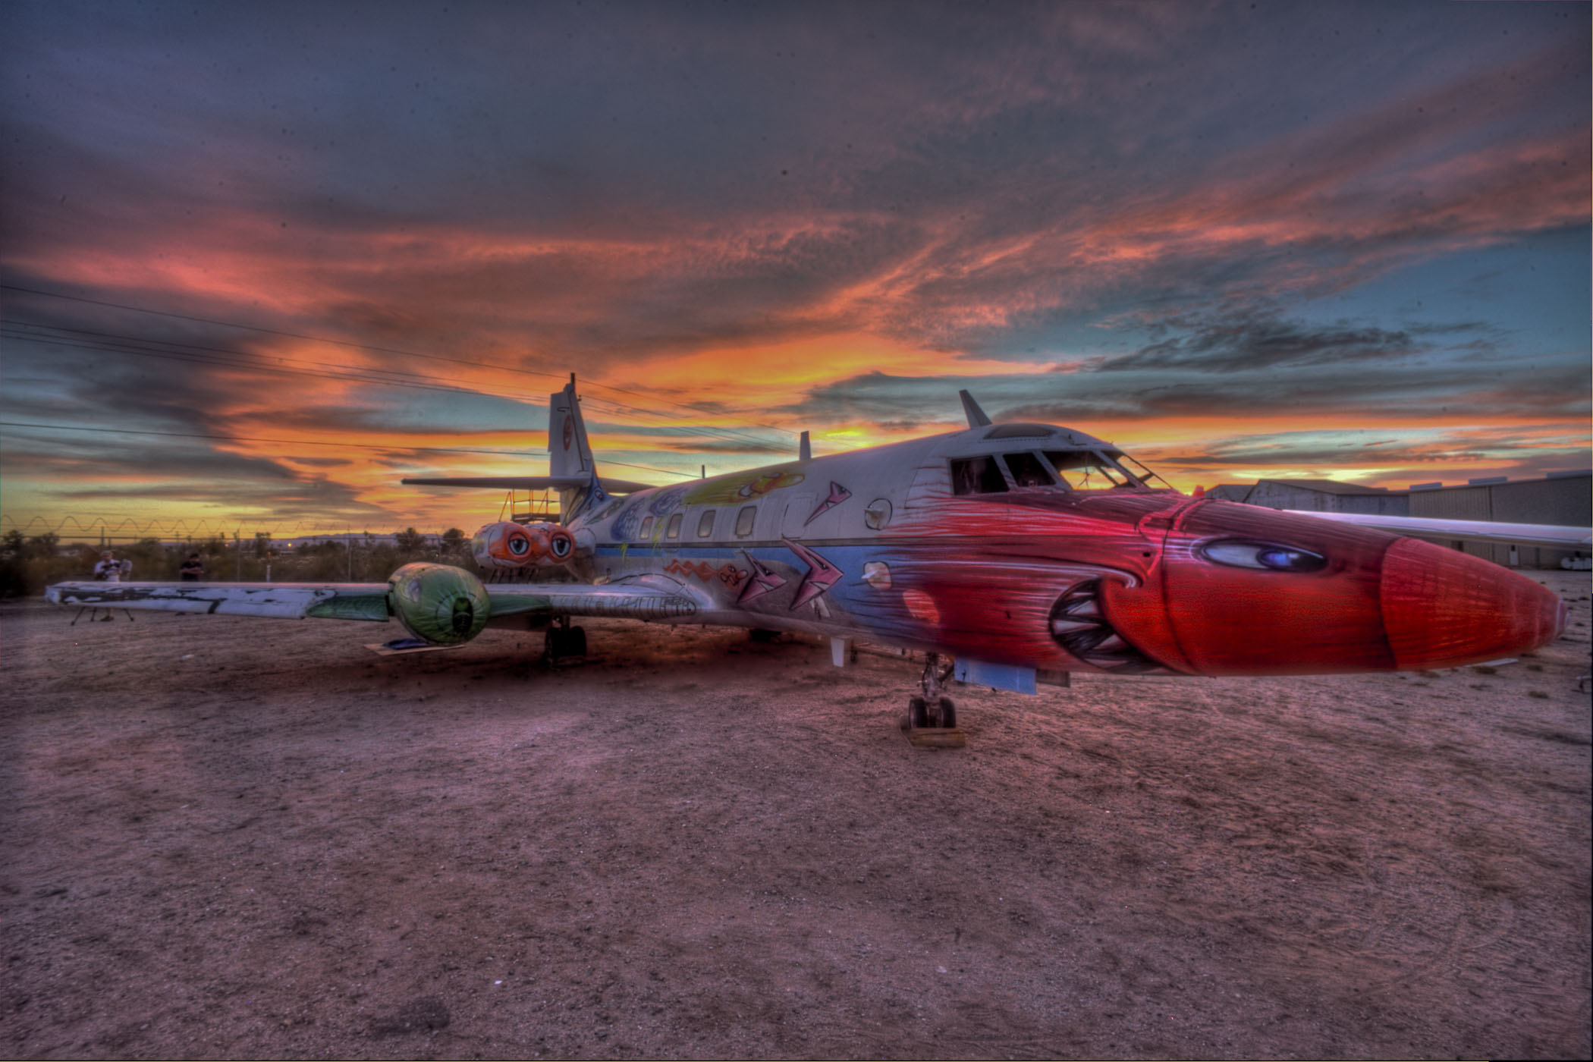

PASMArtPlaneScharfSunset = “Back to Supersonica” at sunset; Photo by Jason Wawro

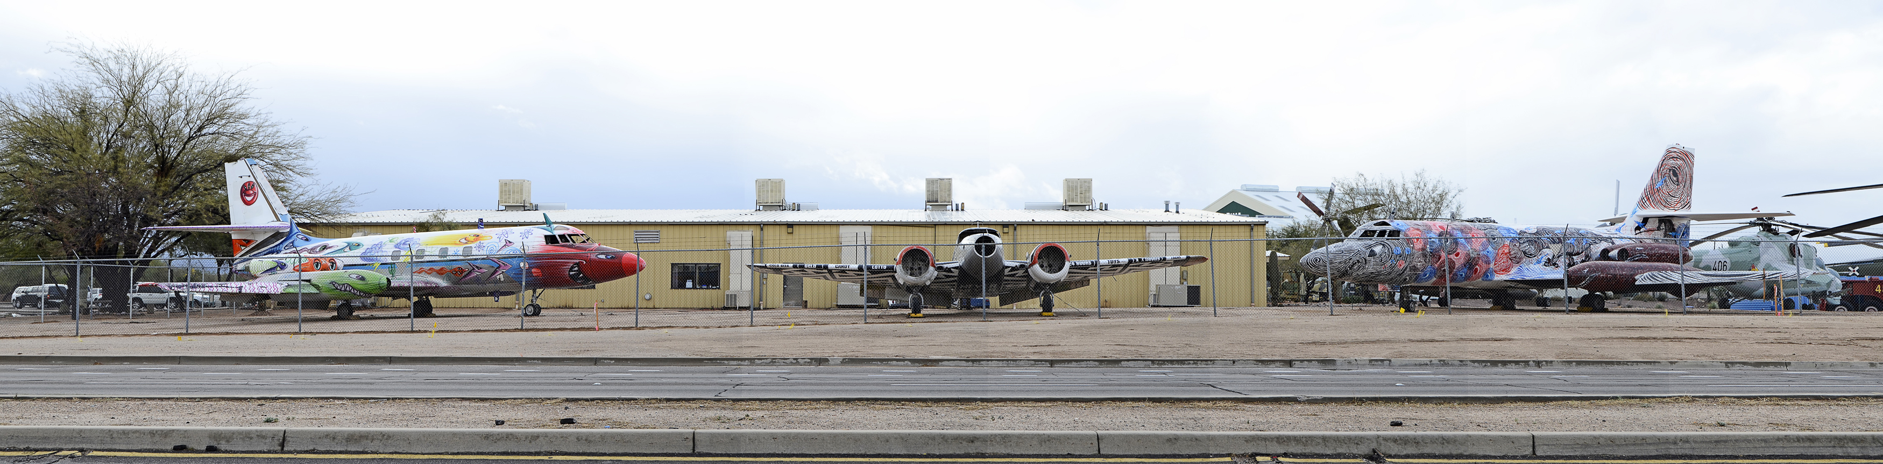PASMRoundTripViewFromValencia = the new smiling view at the entrance to Pima Air & Space Museum (taken from Valencia Road), the “Bone Yard Project: RoundTrip;” photo by John Bezosky

High resolution photos and video are available upon request.

###