[FOR IMMEDIATE RELEASE
Mary E Emich
Director of Marketing, Sales and Visitor Services
Arizona Aerospace Foundation
6000 East Valencia Rd
Tucson, AZ  85756
Phone 520 618-4805
memich@pimaair.org 
](mailto:memich@pimaair.org)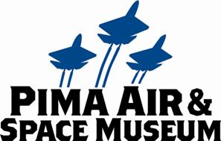

**NASA ORION MOCKUP SPLASHES DOWN AT PIMA AIR & SPACE MUSEUM THROUGH NEW YEAR’S DAY**

Tucson—Dec. 19, 2013 NASA’s Orion Multi-Purpose Crew Vehicle crew module mockup will spend the upcoming winter holidays at the Pima Air and Space Museum.

Per NASA release **J13-021:**

**NASA Orion spacecraft mockup to splash down in Tucson today.**

A test version of NASA’s Orion spacecraft has been on a cross-country road trip for the past week, and will begin a two-week rest stop in Tucson, Ariz. hosted by the Pima Air & Space Museum.

Called the boilerplate test article, it is a full-scale structural mockup of the Orion crew module that will be used for splashdown recovery operations tests off the coast of San Diego in February. These at-sea tests will be conducted in preparation for the Fall 2014 orbital flight test – Exploration Flight Test-1.

The Orion test craft left NASA’s Langley Research Center in Virginia on Dec. 11 and has been making its way to California via truck since then. But the trip will pause for the holidays starting today. The Orion test article is set to arrive between 3 p.m. and 5 p.m. Mountain time today. As the schedule is somewhat flexible, those interested in seeing it arrive can follow @NASA_Orion and #SpotOrion on Twitter for continuous updates on the arrival time.

Once it arrives, the test article will be available to be seen by the public for free for about two hours outside of the museum. Afterward, it will be moved inside the museum gates to the outdoor aircraft exhibits area, where the public can view it up close with paid museum admission.

The test article is scheduled to depart Tucson on Jan. 2 and arrive at the U.S. Navy’s Naval Base San Diego by Jan. 7.

As the test article has made its way across the country, social media users have been tracking its progress and sharing their photos of using the hashtag #SpotOrion.

A map of its route across the country can be seen at:

[**http://www.nasa.gov/content/see-if-you-can-spotorion/**](http://www.nasa.gov/content/see-if-you-can-spotorion/)

The 18,000-pound mockup is a full-sized replica of the Orion spacecraft currently being built at NASA’s Kennedy Space Center. The mockup has already been used in a number of tests to ensure that Orion will be ready for its first mission, Exploration Flight Test-1, scheduled for September 2014. That mission will take Orion to 3,600 miles above the Earth’s surface before returning it at speeds of up to 20,000 miles per hour for a splash landing in the Pacific Ocean.

In February it will be used for an underway recovery test in the Pacific Ocean. For this test, the mockup will be set adrift in open and unstable waters, providing NASA and U.S. Navy the opportunity to recover the capsule and bring it into the well deck of the USS San Diego. While deployed, the team will seek out various sea states in which to practice the capsule recovery procedures. This will help build a knowledge base of how the capsule recovery differs in calm and rough seas and what the true physical limits are.

NASA and the Navy previously used this mockup to practice recovery in calm seas during a stationary recovery test in August where the spacecraft was set adrift in the waters of Naval Station Norfolk in Virginia and recovered into the docked well deck of the USS Arlington. The mockup was also dropped from 25 feet above the water of Langley’s Hydro Impact Basin to simulate different splashdown scenarios.

To learn more about Orion and Exploration Flight Test-1, visit

[**http://www.nasa.gov/orion**](http://www.nasa.gov/orion)

Lockheed Martin’s Deputy Orion Program Manager, Larry Price will be in Tucson for the holidays and will be available for telephone and on-camera interviews.

Photos of the BTA being used in the stationary recovery tests can be found at <http://www.flickr.com/photos/nasaorion/sets/72157635072298379/>.

Video of the BTA in the stationary recovery tests can be found at <http://vimeo.com/81906726>.

[**IF YOU GO**](http://azstarnet.com/if-you-go/article_e05b24f6-9784-11e0-87e2-001cc4c03286.html)

**What:** Orion Multi-Purpose Crew Vehicle crew module mockup on display

**Where:** Pima Air & Space Museum, 6000 E. Valencia Rd.

**When:** Beginning Fri., Dec. 20, 2013, daily through Jan. 1st (except Christmas day) regular museum hours 9 a.m. to 5 p.m., last admittance 4 p.m.

**Cost:** Regular admission rates apply ($15.50 for adults, $12.25 for Pima County residents, seniors $12.50; children ages 7-12 $9, 6 & under free)

**For more information:** [www.pimaair.org](http://www.pimaair.org); 520 574-0462

**ABOUT PIMA AIR & SPACE MUSEUM**

Be wowed at Pima Air & Space Museum, one of the largest aviation museums in the world and the largest non-government-funded in the U.S. (TripAdvisor ranks it in the Top 10% worldwide for excellent ratings.) Its significant collection, 300 strong from around the globe, covers commercial, military and civil aviation alongside more than 125,000+ artifacts, including a moon rock donated by Tucsonan and Astronaut Frank Borman. Be amazed by many all-time great aircraft: the SR-71 Blackbird (the world’s fastest spy plane); a B-29 Superfortress (the WWII bomber that flew higher, farther and faster plus carried more bombs); the world’s smallest bi-plane; the C-54 (the Berlin Airlift’s star flown by the famous “Candy Bomber” Col. USAF (Ret.) Gail Halvorsen, a Tucson-area winter resident); plus planes used as renowned-contemporary-artists’ canvases, including Brazilian graffiti artist Nunca. Explore five large hangars totaling more than 189,000 indoor square feet—four+ football fields­—of air/space craft, heroes’ stories and scientific phenomena. Two+ hangars are dedicated to WWII, one each to the European and Pacific theaters. Pima Air & Space maintains its own aircraft restoration center. It also operates exclusive tours of the “Boneyard,” aka the 309th Aerospace Maintenance and Regeneration Group (AMARG) on Davis-Monthan Air Force Base, plus offers a docent-led tram tour of its 80 acres (additional fees apply). Pima Air & Space Museum is located at 6000 E. Valencia Rd., just off I-10 exit 267, in Tucson. More information can be found at [www.pimaair.org](http://www.pimaair.org/), on Facebook at [www.facebook.com/PimaAirAndSpace](http://www.facebook.com/PimaAirAndSpace), or by calling 520 574-0462.

#

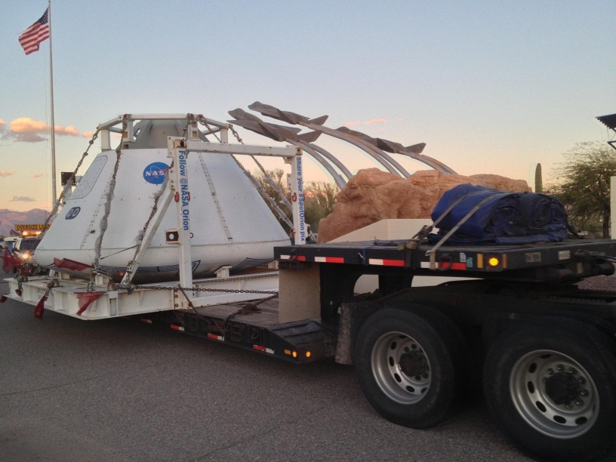

Photo: Orion module entering Pima Air & Space Museum entrance. Photo by Yvonne Morris.